WEEK 1

VACS AI Patient & Grading Issue Report
Final Clinical and Operational Audit
Purpose: This report lists only confirmed system/data problems found by comparing the AI patient interview, the EMR screen shown to the student, and the AI grader. SOAP-writing suggestions and personal review notes have been removed. Repeated problems are listed under each visit because they can affect grading independently on different days.

Quick Guide for Non-Clinical Readers
Term | Plain-language meaning
AI patient | The simulated patient the student interviews.
EMR | The electronic patient chart shown to the student.
Grader / rubric | The AI scoring system and the facts it expects.
A1C | A blood test that reflects average blood sugar over roughly 3 months.
LDL | “Bad” cholesterol; lower values are usually preferred for heart-risk reduction.
UACR | A urine protein test used to measure kidney damage.
PCI/DES | A heart catheter/stent procedure; DES means drug-eluting stent.
NKDA | “No known drug allergies.”
HDL | “Good” cholesterol, another part of a lipid panel.
Triglycerides | A type of blood fat measured on a lipid panel.

Final Review Summary
This final review contains 92 grouped findings across all 9 Week 1 visits. Only confirmed conflicts or missing-information problems are included. Repeated issues are kept under each visit when they can affect grading independently.
Encounter | Grouped issues
Patient A – Maria Gonzalez – Tuesday Initial Visit | 6
Patient A – Maria Gonzalez – Wednesday 3-Month Follow-Up | 10
Patient A – Maria Gonzalez – Thursday 6-Month Follow-Up | 4
Patient B – James Wilson – Tuesday Initial Visit | 17
Patient B – James Wilson – Wednesday 3-Month Follow-Up | 9
Patient B – James Wilson – Thursday 6-Month Follow-Up | 9
Patient C – Linda Martinez – Tuesday Initial Visit | 12
Patient C – Linda Martinez – Wednesday First Follow-Up | 14
Patient C – Linda Martinez – Thursday Final Follow-Up | 11

Patient A – Maria Gonzalez – Tuesday Initial Visit
6 confirmed system/data issues are included for this visit. Items are grouped so one underlying problem is not counted multiple times just because it caused several grader deductions.
# | Issue | Problem type
1 | Prior metformin stomach/GI side effects expected by grader contradicts the fresh AI-patient interview | AI patient and grader disagree
2 | Disease-duration values returned by the AI patient do not match the exact durations required by the grader | AI patient and grader disagree
3 | Surgical history required by the grader contradicts the AI patient’s repeated denial of surgery | AI patient and grader disagree
4 | Alcohol quantity and frequency reported by the AI patient conflict with the grader/rubric | AI patient and grader disagree
5 | Metformin administration timing reported by the AI patient conflicts with the grader’s required dinner timing | EMR and grader disagree
6 | Specific home blood pressure average required by the grader is not available from the AI patient | Required information is unavailable

Issue 1. Prior metformin stomach/GI side effects expected by grader contradicts the fresh AI-patient interview
What the student saw or heard: Maria was asked both whether metformin currently bothers her and whether she has ever had nausea, diarrhea, or stomach problems from metformin, even if those symptoms later resolved. She answered that metformin does not bother her and that she does not recall any prior nausea, diarrhea, or stomach issues from it.
What the grader expected: The grader requires a history of prior metformin GI intolerance that is now resolved and deducted because the SOAP note documented the patient’s denial instead of that hidden positive history.
Why this is a problem: The interview question directly targeted both current and prior GI intolerance. The AI patient returned a negative history while the grader/rubric requires a positive historical fact. The student should not fabricate prior intolerance after the patient explicitly denies it.
Suggested fix: Synchronize the AI-patient history with the grader/rubric. If prior resolved metformin GI intolerance is required, the AI patient should disclose it when directly asked about past metformin GI symptoms.
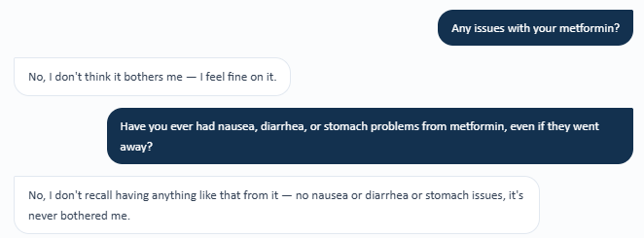
Evidence – Fresh Tuesday AI-patient interview: Maria denies current and prior metformin GI intolerance.
Grader evidence – Rubric/grader expects prior resolved metformin GI intolerance.

Issue 2. Disease-duration values returned by the AI patient do not match the exact durations required by the grader
What the student saw or heard: When asked separately about diabetes, hypertension, and high cholesterol, Maria gave approximate diagnosis timing: diabetes since around 2018 (described as roughly six or seven years), hypertension since around 2016 (about ten years), and high cholesterol since around 2019 (about six years).
What the grader expected: The grader requires exact durations of 8 years for hypertension, 4 years for type 2 diabetes, and 3 years for high cholesterol.
Why this is a problem: The student asked the exact duration questions from the rubric-aligned interview. The AI patient supplied different previous history rather than the values required by the grader/rubric. This is not simply an omitted question.
Suggested fix: Align disease-onset/duration data across the AI patient, previous chart history, and grader/rubric. If the grader requires exact durations, the patient should return those values or the visible chart should display them explicitly.
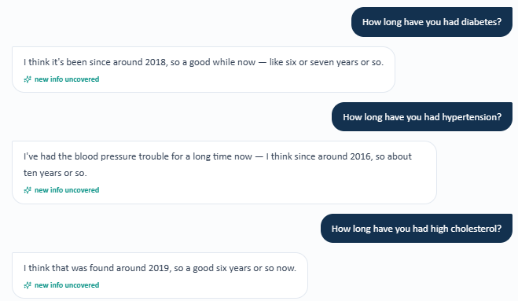
Evidence – Fresh Tuesday AI-patient interview: disease timing/durations provided by Maria.
Grader evidence – Grader requires 8-year high blood pressure, 4-year type 2 diabetes, and 3-year high cholesterol durations.

Issue 3. Surgical history required by the grader contradicts the AI patient’s repeated denial of surgery
What the student saw or heard: Maria repeatedly denied any past surgery or procedures. In the fresh interview she denied ever having surgery and also denied specific surgical examples when probed. She stated that she could not provide an age because she did not recall ever having a procedure.
What the grader expected: The grader requires a prior gallbladder removal (cholecystectomy) and specifically expects the gallbladder removal (cholecystectomy) to have occurred at age 41.
Why this is a problem: A direct denial of all surgical history conflicts with a required hidden gallbladder removal (cholecystectomy). The student cannot safely replace the patient’s explicit response with an undisclosed surgical history.
Suggested fix: Synchronize the AI patient and grader/rubric. If gallbladder removal (cholecystectomy) at age 41 is a required fact, the AI patient should disclose it when asked about prior surgery/procedures, including gallbladder or abdominal surgery.
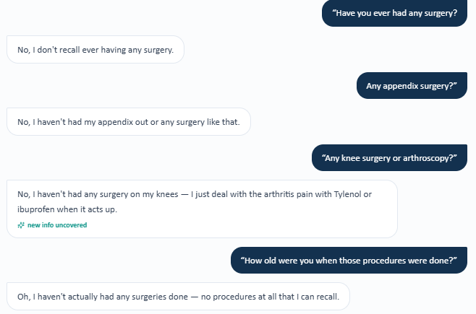
Evidence – Fresh Tuesday AI-patient interview: Maria denies any prior surgery/procedure.
Grader evidence – Grader requires gallbladder removal (cholecystectomy) and age 41.

Issue 4. Alcohol quantity and frequency reported by the AI patient conflict with the grader/rubric
What the student saw or heard: Maria reports rare alcohol use: a small glass of wine on special family occasions or dinners, not on a regular basis.
What the grader expected: The grader expects 1–2 glasses of wine with a weekend frequency.
Why this is a problem: The type of alcohol is consistent, but quantity and frequency are not. The patient specifically characterizes use as rare/special-occasion rather than weekend drinking, so documenting the grader’s hidden history would contradict the interview.
Suggested fix: Use one synchronized alcohol history across the AI patient and rubric, including type, quantity, and frequency. If weekend 1–2-glass use is required, the AI patient should state it when asked how much and how often she drinks.
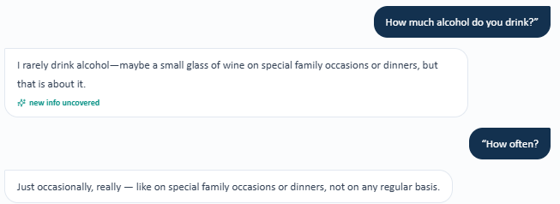
Evidence – Fresh Tuesday AI-patient interview: rare small-glass wine use on special occasions/dinners.
Grader evidence – Grader expects 1–2 glasses on weekends.

Issue 5. Metformin administration timing reported by the AI patient conflicts with the grader’s required dinner timing
What the student saw or heard: When asked how and when she takes her medications, Maria states that she takes the metformin, lisinopril, and “water pill” together in the morning. The interview does not support evening/dinner metformin administration.
What the grader expected: The grader requires metformin XR to be documented as taken by mouth daily with dinner/evening dosing.
Why this is a problem: The grader/rubric requires a timing detail that the AI patient directly contradicts. The SOAP note accurately reflected the fresh patient interview rather than inserting the hidden dinner timing.
Suggested fix: Synchronize metformin administration timing across the medication instructions, AI patient, and grader/rubric. If dinner dosing is required, the AI patient should state that timing when directly asked when medications are taken.
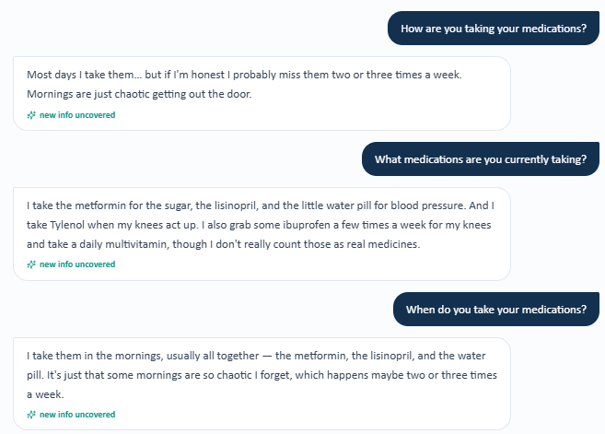
Evidence – Fresh Tuesday AI-patient interview: medications, including metformin, are reported as taken in the morning.
Grader evidence – Grader expects metformin XR evening/dinner timing.

Issue 6. Specific home blood pressure average required by the grader is not available from the AI patient
What the student saw or heard: Maria reports checking BP only once in a while without a set schedule. Readings are usually in the 140s/90s. She explicitly states that she does not keep a written log and, when asked for an average, again says only that it is usually around the 140s/90s.
What the grader expected: The grader expects a specific home BP average rather than a range/approximation and deducts because the note does not provide the required average value.
Why this is a problem: The patient was directly asked for frequency, range, log use, and average. She still did not provide a numeric average. A student should not invent a precise average from an imprecise range, especially when the patient reports no written log.
Suggested fix: If a precise home BP average is graded, make it available: either display the actual log/average in the visible EMR or have the AI patient provide the value when asked for the average. Otherwise, the grader should accept the available range with documentation that no reliable average is available.
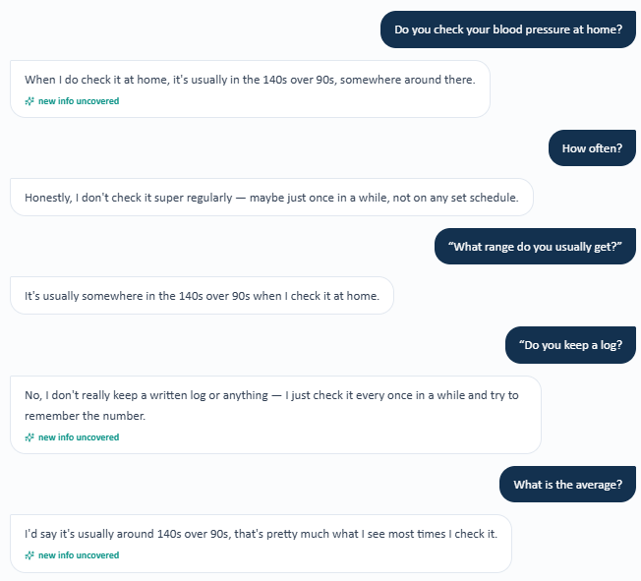
Evidence – Fresh Tuesday AI-patient interview: intermittent BP checks, 140s/90s, no written log, no specific average.
Grader evidence – Grader deducts for absence of the required home BP average.

Patient A – Maria Gonzalez – Wednesday 3-Month Follow-Up
10 confirmed system/data issues are included for this visit. Items are grouped so one underlying problem is not counted multiple times just because it caused several grader deductions.
# | Issue | Problem type
1 | Prior missed-dose frequency required for before/after adherence scoring is not available from the AI patient | Required information is unavailable
2 | The AI patient provides current glucose monitoring details but cannot confirm the rubric-required increase from baseline | Required information is unavailable
3 | Exact chronic-disease durations required by the grader are not available during the Wednesday interview | Required information is unavailable
4 | Gallbladder removal (gallbladder removal (cholecystectomy)) required by the grader/rubric directly contradicts the AI patient’s Wednesday surgical-history denial | AI patient and grader disagree
5 | Detailed family history required by the grader is not available from the Wednesday AI patient | Required information is unavailable
6 | Living-with-husband detail is required by the grader but not returned when the AI patient is directly asked who she lives with | Data / grading mismatch
7 | Alcohol history in the Wednesday AI interview directly conflicts with the rubric’s expected social/weekend use | AI patient and grader disagree
8 | Tdap is visible only as “overdue,” while the grader requires an exact 11-year interval | Data / grading mismatch
9 | The grader requires the prior office BP value 146/92 for trend scoring, but the Wednesday encounter exposes only current values | Required information is unavailable
10 | The grader requires prior LDL-C 112 mg/dL for numeric trend scoring, but the Wednesday EMR exposes only the current LDL-C | EMR and grader disagree

Issue 1. Prior missed-dose frequency required for before/after adherence scoring is not available from the AI patient
What the student saw or heard: Maria reports that she now misses about one dose per week. When directly asked how often she was missing doses before the improvement, she says she does not remember the exact number and can only say it was worse than now.
What the grader expected: The grader expects a quantitative comparison from 2–3 missed doses per week previously to approximately once weekly now.
Why this is a problem: The baseline frequency was directly queried but the AI patient did not return the value the rubric requires. A student should not invent a precise historical frequency after the patient states she cannot remember it.
Suggested fix: Carry the prior adherence frequency into the follow-up patient memory or visible previous history. If 2–3 times weekly is graded, the AI patient should provide that number when asked to compare current versus prior adherence.
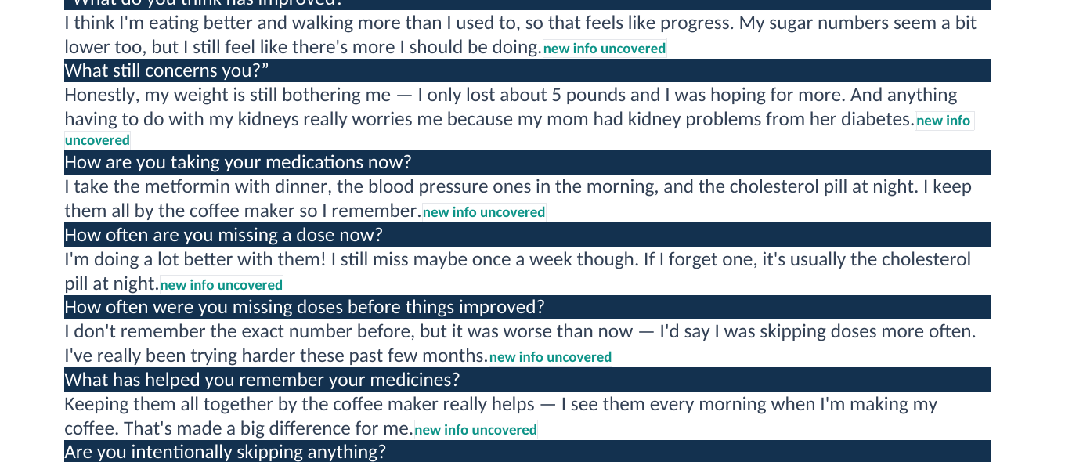
Evidence – Wednesday patient interview: current adherence is ~once weekly, but Maria cannot quantify the prior missed-dose frequency.
Grader evidence – Grader requires quantitative prior adherence for comparison.

Issue 2. The AI patient provides current glucose monitoring details but cannot confirm the rubric-required increase from baseline
What the student saw or heard: Maria reports checking fasting glucose most mornings with readings around 130–150 mg/dL. When specifically asked whether she is checking more often than before, she says she does not know whether the frequency has increased.
What the grader expected: The grader requires an explicit statement that glucose self-monitoring frequency increased compared with the previous visit.
Why this is a problem: The current monitoring frequency and glucose range are available, but the graded previous comparison is not. The student cannot truthfully state that monitoring increased when the patient explicitly cannot confirm that change.
Suggested fix: Carry the prior monitoring frequency into the AI patient’s follow-up memory or expose the prior value in the visible chart. The grader should not require an improvement statement that cannot be obtained.
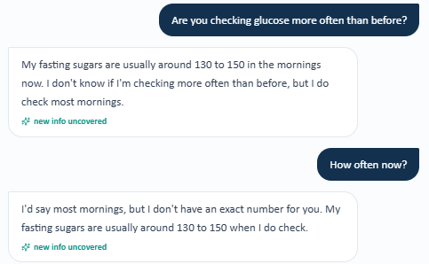
Evidence – Wednesday patient interview: most-morning glucose checks are reported, but increased frequency versus baseline cannot be confirmed.
Grader evidence – Grader deducts because increased glucose-monitoring frequency was not established.

Issue 3. Exact chronic-disease durations required by the grader are not available during the Wednesday interview
What the student saw or heard: Maria was separately asked how long she has had hypertension, diabetes, and high cholesterol. She reports only that each has been present for several years or “a little while” and says she would need to check her records for exact timing.
What the grader expected: The grader requires exact durations of 8 years for hypertension, 4 years for type 2 diabetes, and 3 years for high cholesterol.
Why this is a problem: The interview deliberately targeted all three duration items, yet the AI patient still did not provide the required values. This is a information-availability problem rather than an omitted interview question.
Suggested fix: Synchronize disease duration across previous chart data, AI-patient memory, and the grader/rubric. Exact durations should be visible or returned when directly asked.
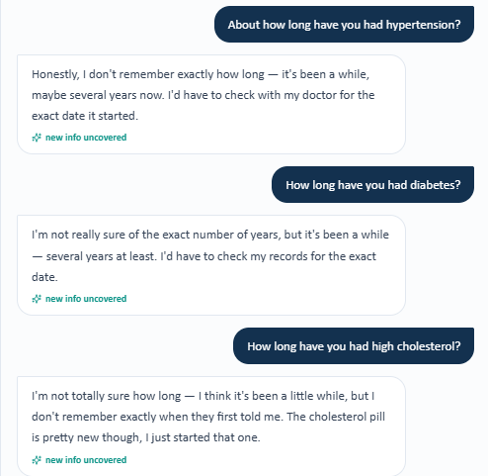
Evidence – Wednesday patient interview: exact high blood pressure, type 2 diabetes, and high cholesterol durations are not recalled.
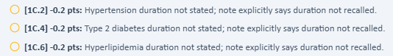
Grader evidence – Grader requires the exact 8-, 4-, and 3-year durations.

Issue 4. Gallbladder removal (gallbladder removal (cholecystectomy)) required by the grader/rubric directly contradicts the AI patient’s Wednesday surgical-history denial
What the student saw or heard: Maria denies prior surgery or procedures. When specifically asked about gallbladder or other abdominal surgery, she again denies having had anything like that.
What the grader expected: The grader expects a prior gallbladder removal (cholecystectomy) and specifically requires the age at surgery (41).
Why this is a problem: This is a direct contradiction after a targeted gallbladder question. The SOAP note accurately documented the fresh Wednesday patient response rather than inserting hidden surgical history.
Suggested fix: If gallbladder removal (cholecystectomy) at age 41 is part of the case, the AI patient should disclose it when asked about surgeries and specifically gallbladder surgery. The grader and patient history should use the same source of truth.
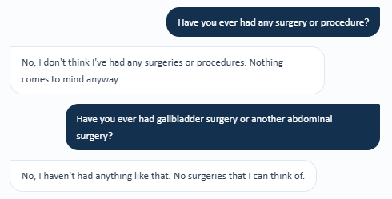
Evidence – Wednesday patient interview: Maria denies any surgery, including gallbladder/abdominal surgery.
Grader evidence – Grader requires the gallbladder removal (cholecystectomy) age, which cannot be documented after the patient denies surgery.

Issue 5. Detailed family history required by the grader is not available from the Wednesday AI patient
What the student saw or heard: When asked for complete family history covering father, mother, brothers, and sisters, Maria recalls only that her mother had kidney problems from diabetes. She says she does not have much else to report about her father or siblings off the top of her head.
What the grader expected: The grader requires paternal hypertension, paternal type 2 diabetes, paternal MI at age 62, maternal hypertension, maternal type 2 diabetes, maternal diabetic kidney disease, and brother with type 2 diabetes.
Why this is a problem: The missing family-history items were explicitly requested. The patient did not surface them, so the student cannot accurately add those hidden details to the SOAP note.
Suggested fix: Persist complete family history across follow-up encounters or make it visible in the follow-up EMR. If these items remain graded, the AI patient should reliably recall them when asked for complete family history.
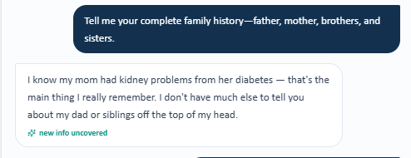
Evidence – Wednesday patient interview: only maternal diabetic kidney disease is recalled; father/sibling history is not available.
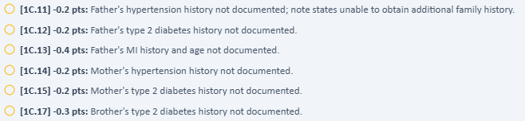
Grader evidence – Multiple paternal, maternal, and sibling family-history items are required.

Issue 6. Living-with-husband detail is required by the grader but not returned when the AI patient is directly asked who she lives with
What the student saw or heard: Maria confirms that she is married. In the same question she is asked who she lives with, but she says she does not have anything else to add and does not state that she lives with her husband.
What the grader expected: The grader requires the full marital/living-status statement: married and lives with husband.
Why this is a problem: The student asked both components of the rubric item in one neutral question. Only marital status was available; the living arrangement remained hidden.
Suggested fix: Ensure the follow-up AI patient can answer household/living-status questions, or display the persistent living arrangement in the visible chart if it remains a graded element.

Evidence – Wednesday patient interview: married is confirmed, but the requested living arrangement is not provided.
Grader evidence – Grader requires “lives with husband.”

Issue 7. Alcohol history in the Wednesday AI interview directly conflicts with the rubric’s expected social/weekend use
What the student saw or heard: When asked “Do you drink alcohol? What and how often?”, Maria states that she does not really drink alcohol and that alcohol is not something she does.
What the grader expected: The grader expects current/social alcohol use with a weekend frequency.
Why this is a problem: The patient gives an explicit negative response to a direct quantity/frequency question. Documenting weekend alcohol use would contradict the AI-patient interview.
Suggested fix: Synchronize alcohol use across the AI patient and grader/rubric. If social/weekend drinking is required, the patient should report it when asked directly.

Evidence – Wednesday patient interview: Maria denies current alcohol use.
Grader evidence – Grader expects social alcohol use on weekends.

Issue 8. Tdap is visible only as “overdue,” while the grader requires an exact 11-year interval
What the student saw or heard: The Wednesday Objective immunization panel shows Tdap as “Overdue.” It does not display an 11-year elapsed interval. The patient also reports that she cannot remember exact vaccine dates.
What the grader expected: The grader requires documentation that the last Tdap was 11 years ago and deducts when only “overdue” is documented.
Why this is a problem: The note accurately reflects the information available in the Wednesday encounter. A precise elapsed interval should not be required unless the underlying last-dose date or interval is exposed to the student.
Suggested fix: If the 11-year interval is graded, display the last Tdap date and/or “11 years ago” in the visible immunization record. Otherwise, accept accurate documentation of “overdue.”
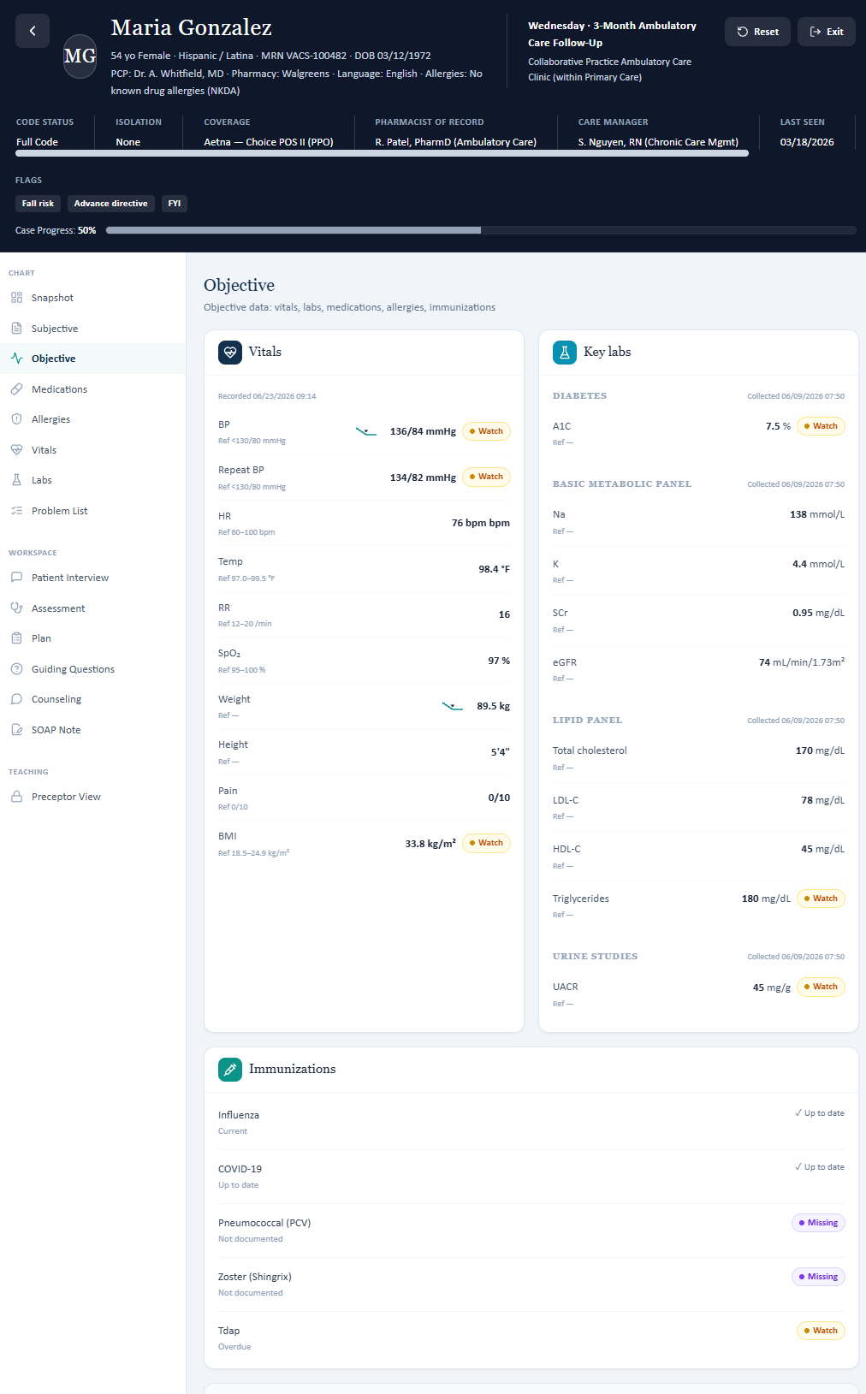
Evidence – Wednesday Objective immunization panel: Tdap is marked overdue, but no 11-year interval is shown.

Issue 9. The grader requires the prior office BP value 146/92 for trend scoring, but the Wednesday encounter exposes only current values
What the student saw or heard: The Wednesday encounter displays current BP data (136/84 mmHg, repeat 134/82 mmHg, and home average approximately 134/82 mmHg). The active-problem/BPA views emphasize current improvement but do not show the prior office BP of 146/92 mmHg.
What the grader expected: The grader requires the assessment to explicitly state the numeric trend from 146/92 to 136/84 mmHg.
Why this is a problem: A follow-up rubric can reasonably grade trends only when the prior baseline is available in the follow-up student view. Here, the patient and current EMR provide current values, while the exact prior office value is hidden.
Suggested fix: Add prior-visit numeric BP values to a visible trend/baseline section in the follow-up EMR, or relax the rubric to accept “improved” when the previous exact value is not exposed.
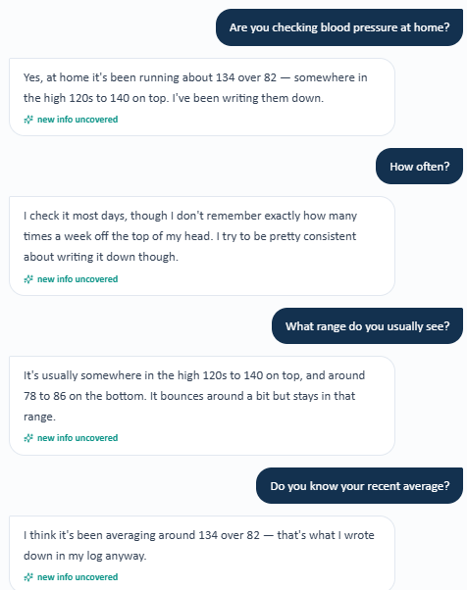
Evidence A-W9a – Wednesday patient interview: current home BP data and average are available.
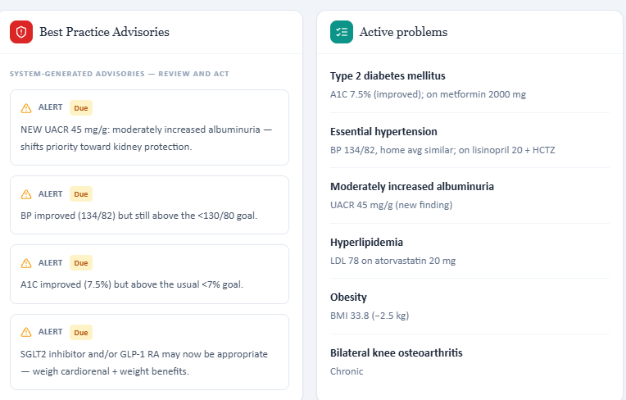
Evidence A-W9b – Wednesday BPA/active-problem view shows current BP status but not the prior 146/92 office value.
Grader evidence – Grader requires the prior 146/92 value for comparison.

Issue 10. The grader requires prior LDL-C 112 mg/dL for numeric trend scoring, but the Wednesday EMR exposes only the current LDL-C
What the student saw or heard: The Wednesday lipid panel shows LDL-C 78 mg/dL and labels it “improved on statin.” The active-problem view similarly lists LDL 78 on atorvastatin 20 mg. The prior LDL-C of 112 mg/dL is not displayed in the supplied Wednesday views.
What the grader expected: The grader requires the assessment to document LDL improvement from 112 to 78 mg/dL.
Why this is a problem: The student can accurately state that LDL improved, but the exact numeric baseline cannot be documented unless it is carried into the follow-up EMR. Requiring a hidden prior value creates a grading/data-exposure mismatch.
Suggested fix: Expose the previous LDL-C value in the follow-up lipid panel or a visible trend section if the rubric requires the exact 112→78 mg/dL comparison.
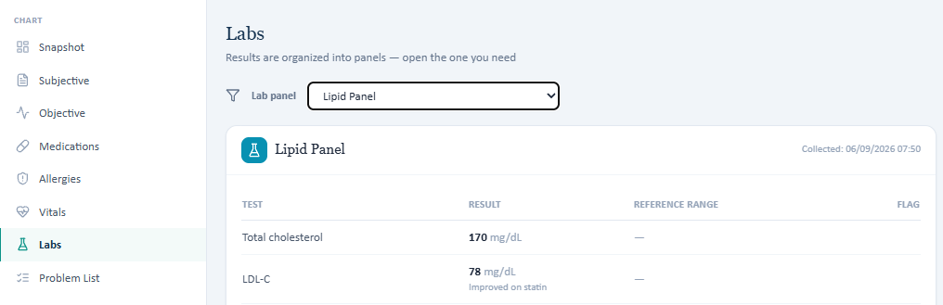
Evidence A-W10a – Wednesday lipid panel: current LDL-C 78 mg/dL is visible and labeled improved on statin; prior 112 mg/dL is not displayed.
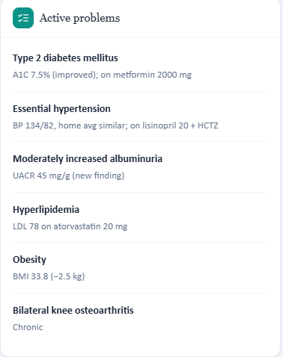
Evidence A-W10b – Wednesday active-problem view again shows current LDL 78 on atorvastatin 20 mg without the prior numeric LDL.
Grader evidence – Grader requires prior LDL-C 112 mg/dL for the numeric trend.

Patient A – Maria Gonzalez – Thursday 6-Month Follow-Up
4 confirmed system/data issues are included for this visit. Items are grouped so one underlying problem is not counted multiple times just because it caused several grader deductions.
# | Issue | Problem type
1 | Gallbladder removal (gallbladder removal (cholecystectomy)) required by the grader/rubric directly contradicts the Thursday AI patient’s targeted surgical-history denial | AI patient and grader disagree
2 | Detailed family history required by the Thursday grader is not available from the AI patient | Required information is unavailable
3 | Thursday alcohol history directly conflicts with the rubric’s expected social alcohol use | AI patient and grader disagree
4 | Prior LDL-C 112 mg/dL is required for numeric trend scoring but is not exposed in the Thursday visible lipid panel | Required information is unavailable

Issue 1. Gallbladder removal (gallbladder removal (cholecystectomy)) required by the grader/rubric directly contradicts the Thursday AI patient’s targeted surgical-history denial
What the student saw or heard: Maria was directly asked whether she had ever had any surgery or procedure, including gallbladder surgery. She responded that she had not had any surgeries or procedures and specifically did not recall gallbladder surgery.
What the grader expected: The grader expects a past surgical history of gallbladder removal (cholecystectomy) and deducts because the submitted SOAP note accurately documents the patient’s denial.
Why this is a problem: This is a direct contradiction after a neutral, procedure-specific question. The student cannot safely document a gallbladder removal (cholecystectomy) when the AI patient explicitly denies it.
Suggested fix: Synchronize the AI-patient memory with the grader/rubric. If gallbladder removal (cholecystectomy) is part of the required case history, the AI patient should disclose it when asked generally about surgery and specifically about gallbladder surgery.
Evidence – Thursday patient interview: Maria explicitly denies surgery, including gallbladder surgery.
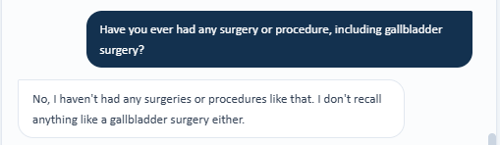
Grader evidence – Grader requires gallbladder removal (cholecystectomy) despite the direct patient denial.

Issue 2. Detailed family history required by the Thursday grader is not available from the AI patient
What the student saw or heard: When asked for her complete family history, Maria states only that her mother had kidney problems and that this is what worries her most. She says she does not have much else to share.
What the grader expected: The grader requires paternal hypertension, paternal type 2 diabetes, paternal MI at age 62, maternal hypertension, maternal type 2 diabetes, maternal diabetic kidney disease, and a brother with type 2 diabetes.
Why this is a problem: The interview directly requests a complete family history, but the AI patient does not return the required previous facts. The student should not invent paternal or sibling history or convert the patient’s nonspecific statement of maternal 'kidney problems' into diabetic kidney disease without supporting information.
Suggested fix: Persist the complete family history in the AI patient across follow-up visits and/or make it visible in the follow-up EMR. If these facts remain graded, they must be available when the student asks for complete family history.
Evidence – Thursday patient interview: only maternal kidney problems are available; the remaining family history is unavailable.
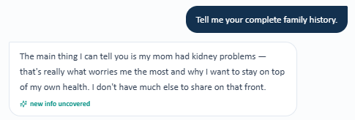
Grader evidence – Grader requires multiple paternal, maternal, and sibling family-history details.
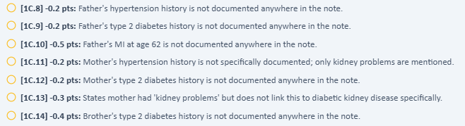

Issue 3. Thursday alcohol history directly conflicts with the rubric’s expected social alcohol use
What the student saw or heard: Maria is directly asked whether she drinks alcohol and responds, “I don't really drink, no.”
What the grader expected: The grader expects social alcohol use and deducts because the SOAP note reflects the patient’s negative response.
Why this is a problem: The patient gives a clear negative answer to a direct alcohol-use question. Documenting social alcohol use instead would contradict the AI-patient interview.
Suggested fix: Synchronize alcohol-use history across the AI patient and grader/rubric. If social alcohol use is required, the AI patient should report it when directly asked.
Evidence – Thursday patient interview: Maria denies meaningful alcohol use.
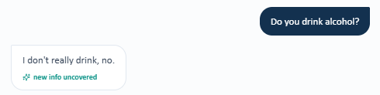
Grader evidence – Grader expects documented social alcohol use.

Issue 4. Prior LDL-C 112 mg/dL is required for numeric trend scoring but is not exposed in the Thursday visible lipid panel
What the student saw or heard: The Thursday lipid panel displays total cholesterol 158 mg/dL, LDL-C 70 mg/dL, HDL-C 48 mg/dL, and triglycerides 155 mg/dL. The current LDL is visible, but the panel does not show a previous/baseline LDL-C of 112 mg/dL.
What the grader expected: The grader requires the assessment to document an LDL-C trend from 112 mg/dL to 70 mg/dL and deducts when only the current value is stated.
Why this is a problem: A student can accurately document the visible LDL-C of 70 mg/dL and that control is improved, but cannot supply an exact prior value that is not exposed in the current follow-up EMR.
Suggested fix: Display the prior LDL-C value in the follow-up lipid panel or a visible previous trend section whenever the rubric requires an exact numeric comparison.
Evidence – Thursday lipid panel: current LDL-C 70 mg/dL is shown, but the prior 112 mg/dL value is not displayed.
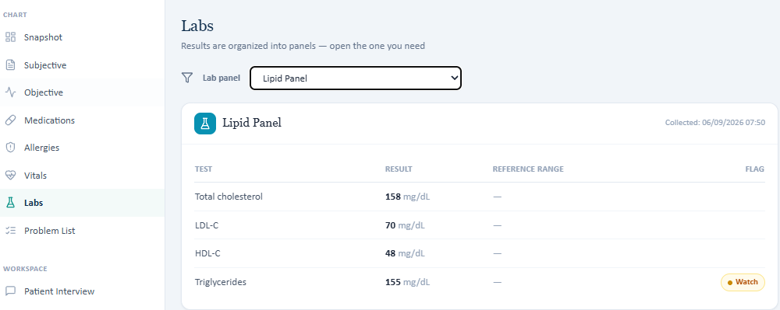
Grader evidence – Grader requires the hidden prior LDL-C value of 112 mg/dL for trend scoring.

Patient B – James Wilson – Tuesday Initial Visit
17 confirmed system/data issues are included for this visit. Items are grouped so one underlying problem is not counted multiple times just because it caused several grader deductions.
# | Issue | Problem type
1 | Expected mild increased thirst directly conflicts with the AI patient’s denial of increased thirst | AI patient and grader disagree
2 | Exact empagliflozin cost (> $500/month) is graded but cannot be obtained from the AI patient | Required information is unavailable
3 | Frequency of cost-driven medication stretching is graded as several times per year but cannot be quantified by the AI patient | Required information is unavailable
4 | Home blood pressure monitoring, range, and average directly contradict the AI patient interview | AI patient and grader disagree
5 | Home glucose monitoring and fasting range directly contradict the AI patient interview | AI patient and grader disagree
6 | Exact diabetes, hypertension, and high cholesterol durations are required but not available | Required information is unavailable
7 | Appendectomy and knee arthroscopy required by the grader are directly denied by the AI patient | AI patient and grader disagree
8 | Former-smoker / 20-pack-year history directly contradicts the AI patient | AI patient and grader disagree
9 | Expected limited activity/yard-work history is not reproducibly available | Data / grading mismatch
10 | Convenience-food and sugary-beverage intake expected by the grader cannot be established from the AI patient | Required information is unavailable
11 | Prior A1C trend values in the visible EMR do not match the grader/rubric | EMR and grader disagree
12 | Sodium value differs between the Tuesday EMR and grader/rubric | EMR and grader disagree
13 | Potassium value differs between the Tuesday EMR and grader/rubric | EMR and grader disagree
14 | Total cholesterol 196 mg/dL is graded but not displayed in the Tuesday All Labs panel | Required information is unavailable
15 | HDL-C value differs between the Tuesday EMR and grader/rubric | EMR and grader disagree
16 | Triglyceride value differs between the Tuesday EMR and grader/rubric | EMR and grader disagree
17 | Shingrix (shingles vaccine) gap is graded but not clearly exposed in the visible data | Data / grading mismatch

Issue 1. Expected mild increased thirst directly conflicts with the AI patient’s denial of increased thirst
What the student saw or heard: When directly asked about fatigue, increased thirst, and increased urination, James reported feeling somewhat more tired but stated that he had not noticed increased thirst or needing to urinate more.
What the grader expected: The grader expects mild polydipsia and deducts because the SOAP note documents the patient’s denial of increased thirst.
Why this is a problem: The student documented the fresh AI-patient response. A positive symptom should not be inferred when the AI patient explicitly denies it.
Suggested fix: Synchronize the AI-patient symptom history with the grader/rubric. If mild polydipsia is required, the AI patient should disclose it when asked directly about thirst.
Evidence – Patient interview: James denies increased thirst/urination while endorsing fatigue.
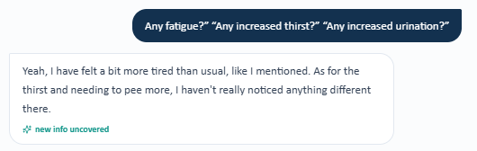
Grader evidence – Grader expects mild polydipsia.

Issue 2. Exact empagliflozin cost (> $500/month) is graded but cannot be obtained from the AI patient
What the student saw or heard: James clearly reports that Jardiance/empagliflozin was prescribed but never picked up because it was too expensive. When asked for the exact pharmacy price, he states that he does not remember the number and only recalls that it was far beyond what he could afford on a fixed income.
What the grader expected: The grader requires the specific figure of more than $500 per month and deducts when the note accurately states that the exact amount was unavailable.
Why this is a problem: The interview establishes the affordability barrier but not the hidden dollar amount. The student should not fabricate a precise cost.
Suggested fix: If the exact price is graded, program the AI patient to provide it when directly asked or display the cost in the visible chart.
Evidence – Patient interview: empagliflozin never started due to cost; exact price cannot be recalled.
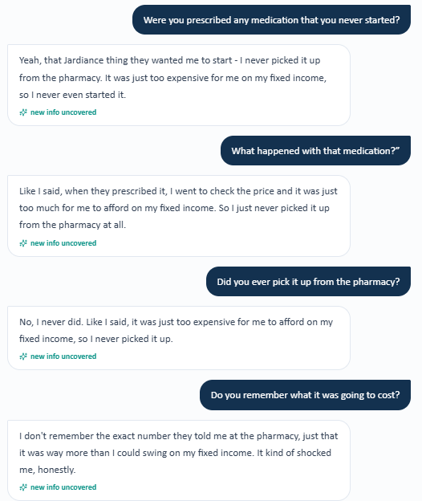
Grader evidence – Grader requires a specific >$500/month figure.

Issue 3. Frequency of cost-driven medication stretching is graded as several times per year but cannot be quantified by the AI patient
What the student saw or heard: James reports taking pills every other day when money is tight, especially around refill time while waiting for his pension check. When asked how many times per year this occurs, he states that he has never counted and cannot provide an exact annual frequency.
What the grader expected: The grader expects a quantified frequency such as several times per year.
Why this is a problem: The behavior is available, but the exact annual frequency is not. Converting the patient’s vague frequency into a precise number would be unsupported.
Suggested fix: If annual frequency is required for grading, the AI patient should provide a reproducible frequency when asked directly.
Evidence – Patient interview: dose stretching occurs around refill time, but annual frequency cannot be quantified.
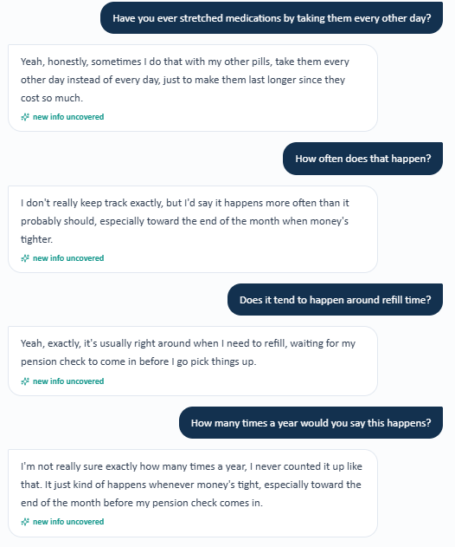
Grader evidence – Grader deducts because frequency per year was not quantified.

Issue 4. Home blood pressure monitoring, range, and average directly contradict the AI patient interview
What the student saw or heard: James repeatedly states that he does not own a home BP machine, never checks at home, keeps no log, and therefore has no home BP range or average.
What the grader expected: The grader expects home BP monitoring 1–2 times weekly, readings in the high 140s/90s, and a home BP average/log value.
Why this is a problem: This is a direct contradiction across multiple targeted questions. Recommending a new monitor is appropriate based on the AI interview but is penalized because hidden data imply monitoring already occurs.
Suggested fix: Synchronize home BP behavior and values across the AI patient, hidden grader/rubric, and visible chart.
Evidence – Patient interview: no home BP monitor, readings, log, or average.
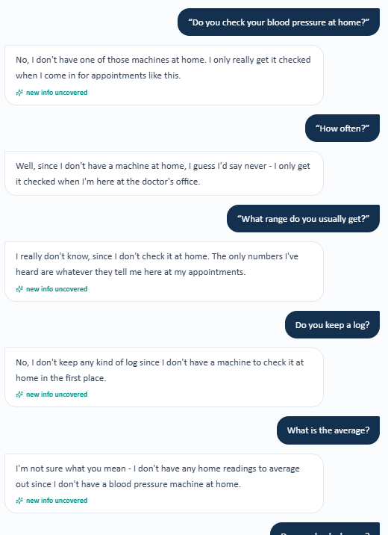
Grader evidence – Grader expects 1–2x/week monitoring and high-140s/90s home values.

Issue 5. Home glucose monitoring and fasting range directly contradict the AI patient interview
What the student saw or heard: James states that he has no glucose meter, never checks glucose at home, and cannot provide fasting readings.
What the grader expected: The grader expects home glucose monitoring a few times weekly and a fasting glucose range.
Why this is a problem: The student cannot safely document home glucose values after the AI patient explicitly denies having a meter or readings.
Suggested fix: Synchronize home glucose monitoring behavior and values across the AI patient and grader/rubric.
Evidence – Patient interview: no meter, no home glucose checks, and no fasting range.
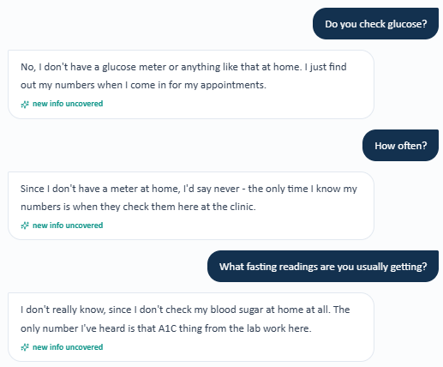
Grader evidence – Grader expects few-times-weekly monitoring and fasting glucose data.

Issue 6. Exact diabetes, hypertension, and high cholesterol durations are required but not available
What the student saw or heard: James is asked separately how long he has had diabetes, hypertension, and high cholesterol. He repeatedly states that the diagnoses have been present for a while but cannot provide exact years.
What the grader expected: The grader expects type 2 diabetes for 10 years, hypertension for 12 years, and high cholesterol for 8 years.
Why this is a problem: The student specifically attempted to obtain all three durations. Exact hidden durations should not be invented when the AI patient cannot provide them.
Suggested fix: Make the exact durations available from the AI patient or visible in the visible problem list if they are required scoring elements.
Evidence B-T6a – Patient interview: diabetes duration cannot be recalled exactly.
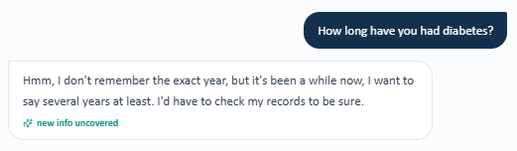
Evidence B-T6b – Patient interview: hypertension duration cannot be recalled exactly.
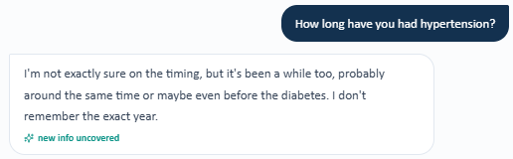
Evidence B-T6c – Patient interview: high cholesterol duration cannot be recalled exactly.

Grader evidence – Grader requires exact 10-, 12-, and 8-year durations.


Issue 7. Appendectomy and knee arthroscopy required by the grader are directly denied by the AI patient
What the student saw or heard: James denies any prior surgery. He is then specifically asked about appendix surgery and knee surgery/arthroscopy and again denies both, stating that he has not had surgeries or procedures.
What the grader expected: The grader expects an appendectomy and knee arthroscopy and deducts because the SOAP note reflects the patient’s denial.
Why this is a problem: This is a direct contradiction after procedure-specific questioning. The student should not document surgeries that the AI patient explicitly denies.
Suggested fix: Synchronize the AI-patient surgical history with the grader/rubric, including the required procedures/ages when asked.
Evidence – Patient interview: James denies surgery, appendectomy, and knee arthroscopy.
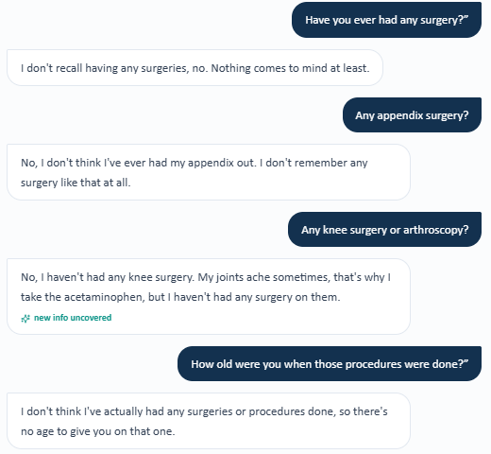
Grader evidence – Grader expects appendectomy and knee arthroscopy.

Issue 8. Former-smoker / 20-pack-year history directly contradicts the AI patient
What the student saw or heard: James is asked whether he has ever smoked, how much he smoked, for how many years, and when he quit. He repeatedly states that he has never smoked or used tobacco products in his life.
What the grader expected: The grader expects former-smoker status, 20 pack-years, and quitting 10 years ago.
Why this is a problem: The AI patient provides an unequivocal lifetime never-smoker history. Replacing it with hidden former-smoking data would make the SOAP note inconsistent with the interview.
Suggested fix: Synchronize tobacco history between the AI patient and grader/rubric.
Evidence – Patient interview: repeated lifetime never-smoking history.
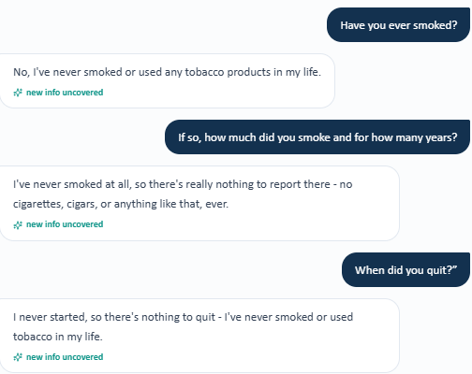
Grader evidence – Grader expects former smoker, quit 10 years ago, 20 pack-years.

Issue 9. Expected limited activity/yard-work history is not reproducibly available
What the student saw or heard: When asked about physical activity, James says he is unsure and thinks he may move around less since retirement. When specifically asked about yard work, he says he does not recall doing much yard work regularly.
What the grader expected: The grader expects limited activity with occasional yard work and gives only partial credit to the available response.
Why this is a problem: The rubric requires a lifestyle detail that the AI patient does not clearly provide when asked directly.
Suggested fix: If occasional yard work is a required history item, make that information reliably available from the AI patient.
Evidence – Patient interview: vague activity history and no recalled regular yard work.
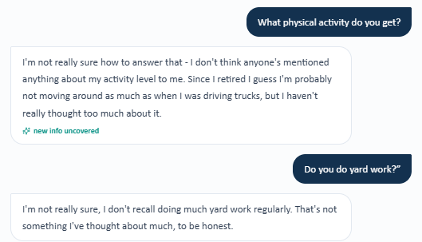
Grader evidence – Grader expects limited activity/yard work.

Issue 10. Convenience-food and sugary-beverage intake expected by the grader cannot be established from the AI patient
What the student saw or heard: James is asked directly how often he eats convenience foods and what sugary beverages he drinks. He states that he does not track convenience foods, his wife handles most cooking, and he is unsure about sugary beverages and does not think he drinks much of them.
What the grader expected: The grader expects quantified/documented convenience-food intake and sugary-beverage use.
Why this is a problem: The student asked targeted questions but did not receive the hidden lifestyle facts. Those details should not be invented.
Suggested fix: Expose these lifestyle details through the AI patient when directly asked if they are required for grading.
Evidence – Patient interview: convenience-food and sugary-beverage details cannot be quantified.
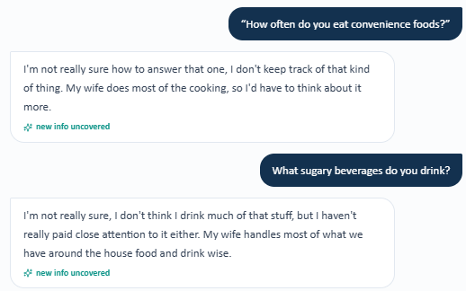
Grader evidence – Grader deducts for both unavailable lifestyle details.


Issue 11. Prior A1C trend values in the visible EMR do not match the grader/rubric
What the student saw or heard: The Tuesday All Labs panel shows A1C 8.8% with a prior value of 8.3% and a worsening trend. No 12-month value is displayed in the provided lab panel.
What the grader expected: The grader expects a 6-month A1C of 8.4%, a 12-month A1C of 8.0%, and a three-point rising trend.
Why this is a problem: The student is penalized for accurately transcribing the visible EMR. This is an objective previous-data mismatch, not an interview/documentation omission.
Suggested fix: Align the prior A1C values in the visible EMR with the grader/rubric or display the complete expected three-point trend.
Grader evidence – Grader expects 8.4% at 6 months and 8.0% at 12 months.
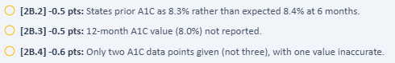

Issue 12. Sodium value differs between the Tuesday EMR and grader/rubric
What the student saw or heard: The visible All Labs panel reports sodium 139 mEq/L.
What the grader expected: The grader expects sodium 138 mEq/L and deducts because 139 mEq/L was documented.
Why this is a problem: This is a direct objective-data mismatch. The SOAP note reflects the visible chart value.
Suggested fix: Synchronize sodium across the visible laboratory panel and grader/rubric.

Issue 13. Potassium value differs between the Tuesday EMR and grader/rubric
What the student saw or heard: The visible All Labs panel reports potassium 4.2 mEq/L.
What the grader expected: The grader expects potassium 4.3 mEq/L and deducts for documenting 4.2 mEq/L.
Why this is a problem: The student is penalized for using the displayed laboratory value.
Suggested fix: Synchronize potassium across the visible laboratory panel and grader/rubric.

Issue 14. Total cholesterol 196 mg/dL is graded but not displayed in the Tuesday All Labs panel
What the student saw or heard: The visible laboratory panel lists A1C, sodium, potassium, SCr, eGFR, UACR, LDL-C, HDL-C, and triglycerides but does not display a total cholesterol value.
What the grader expected: The grader expects total cholesterol 196 mg/dL and deducts when the note states that the value is not provided.
Why this is a problem: This is a hidden objective-data issue. A precise laboratory result should not be invented when it is absent from the visible panel.
Suggested fix: Display total cholesterol 196 mg/dL in the Tuesday lab panel if it is a required grading element.

Issue 15. HDL-C value differs between the Tuesday EMR and grader/rubric
What the student saw or heard: The visible All Labs panel reports HDL-C 41 mg/dL.
What the grader expected: The grader expects HDL-C 42 mg/dL and deducts for documenting the displayed 41 mg/dL value.
Why this is a problem: This is a direct objective-data mismatch.
Suggested fix: Synchronize HDL-C across the visible lab panel and grader/rubric.

Issue 16. Triglyceride value differs between the Tuesday EMR and grader/rubric
What the student saw or heard: The visible All Labs panel reports triglycerides 212 mg/dL.
What the grader expected: The grader expects triglycerides 235 mg/dL and deducts for documenting the visible 212 mg/dL value.
Why this is a problem: This is a direct objective-data mismatch.
Suggested fix: Synchronize triglycerides across the visible lab panel and grader/rubric.

Issue 17. Shingrix (shingles vaccine) gap is graded but not clearly exposed in the visible data
What the student saw or heard: The visible immunization panel shows influenza current, COVID-19 current, pneumococcal not documented, and Tdap last documented 12 years ago. A Shingrix/RZV line is not shown in the supplied immunization screenshot. When asked about COVID, pneumonia, and Shingrix, James states that he does not remember his vaccine history.
What the grader expected: The grader expects Shingrix/RZV to be clearly documented as not documented/a preventive-care gap and deducts when the SOAP note describes the status as unclear.
Why this is a problem: Both the visible panel and AI patient fail to provide a definitive RZV status while the grader requires one.
Suggested fix: Expose an explicit Shingrix/RZV status in the visible immunization panel and/or AI-patient history if it is a graded item.
Evidence B-T17a – Tuesday EMR immunization panel: no Shingrix/RZV row is visible.
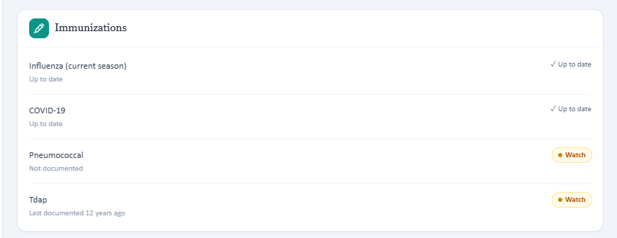
Evidence B-T17b – Patient interview: James cannot recall COVID, pneumococcal, or Shingrix history.

Grader evidence – Grader expects Shingrix to be identified as not documented/a gap.

Patient B – James Wilson – Wednesday 3-Month Follow-Up
9 confirmed system/data issues are included for this visit. Items are grouped so one underlying problem is not counted multiple times just because it caused several grader deductions.
# | Issue | Problem type
1 | Lifetime tobacco history from the AI patient directly contradicts the grader/rubric | AI patient and grader disagree
2 | Appendectomy and knee arthroscopy required by grader contradict explicit AI-patient denials | AI patient and grader disagree
3 | Home blood pressure monitoring expected by grader contradicts the AI-patient interview | AI patient and grader disagree
4 | Home glucose monitoring expected by grader contradicts the AI-patient response | AI patient and grader disagree
5 | Exact disease durations are graded even though the AI patient cannot provide them | Data / grading mismatch
6 | Lifestyle and walking-program details required by grader are not available from the AI patient | Required information is unavailable
7 | Occupation and marital/living status are graded but the AI patient cannot provide them | Required information is unavailable
8 | Preventive-care status is hidden: the EMR immunization panel is blank and the AI patient is unsure | Required information is unavailable
9 | Total cholesterol 178 mg/dL is graded but absent from the visible laboratory panel | Data / grading mismatch

Issue 1. Lifetime tobacco history from the AI patient directly contradicts the grader/rubric
What the student saw or heard: James was specifically asked whether he currently uses tobacco or has ever used tobacco in his life. He answered that he had never smoked or used tobacco products.
What the grader expected: The grader states that James is a former smoker with a 20 pack-year history who quit 10 years ago. It labels the “never smoker” documentation unsafe because smoking history affects cardiovascular risk stratification.
Why this is a problem: The AI patient and the grader/rubric contain mutually exclusive lifetime tobacco histories. The student cannot safely document a 20 pack-year history after the patient explicitly denies ever using tobacco.
Suggested fix: Synchronize lifetime tobacco history across the AI patient, previous chart data, and grader. If former-smoking history is required, the patient should disclose it when directly asked about lifetime tobacco use.

Evidence – Wednesday AI patient explicitly reports never using tobacco.
Grader evidence – Grader requires former-smoker status and a 20 pack-year history.

Issue 2. Appendectomy and knee arthroscopy required by grader contradict explicit AI-patient denials
What the student saw or heard: James first denied prior surgeries/procedures. A later targeted follow-up specifically asked about appendix removal, knee surgery/arthroscopy, gallbladder surgery, heart procedures, or any other operation; he again denied those procedures.
What the grader expected: The grader requires appendectomy at age 19 and knee arthroscopy at age 51 and treats the patient’s denial as inaccurate documentation.
Why this is a problem: The exact procedures used by the hidden key were directly named in the interview and denied. This is stronger than an ordinary omission; the AI patient and grader are presenting different surgical histories.
Suggested fix: Align the AI-patient surgical history with the grader/rubric. If appendectomy and knee arthroscopy are required, the patient should disclose them when specifically asked.

Evidence – Initial Wednesday surgical-history question and denial.
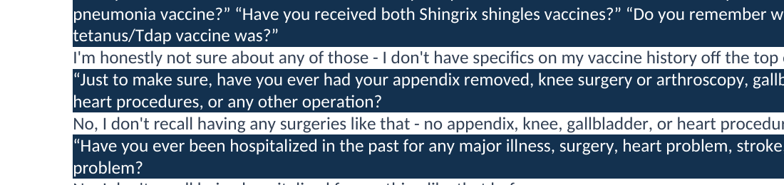
Evidence – Targeted follow-up specifically names appendix and knee surgery/arthroscopy and is still denied.
Grader evidence – Grader requires appendectomy and knee arthroscopy.

Issue 3. Home blood pressure monitoring expected by grader contradicts the AI-patient interview
What the student saw or heard: James was directly asked for home BP readings and stated that he does not really check blood pressure at home. When asked about technique, he again stated that he does not check at home and therefore has no technique to report.
What the grader expected: The grader expects a home BP range/log average and penalizes the note for failing to use home readings to corroborate office BP control.
Why this is a problem: The SOAP note followed the AI-patient interview. A student should not invent a home BP log, average, or technique when the AI patient explicitly says home monitoring is not occurring.
Suggested fix: Make the home BP frequency/range/log available in the visible record or have the AI patient provide the same information when asked. The grader should not penalize documentation that accurately reflects an explicit denial.
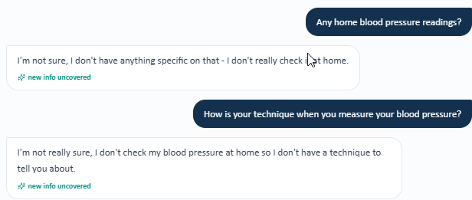
Evidence – James reports no home BP monitoring and no home technique.
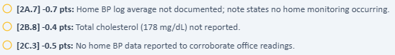
Grader evidence – Home BP log average is required despite the interview denial.
Grader evidence – Assessment also deducts for not referencing a home BP average.

Issue 4. Home glucose monitoring expected by grader contradicts the AI-patient response
What the student saw or heard: When asked for blood glucose readings, James stated that he did not have specific numbers and does not really check glucose at home himself.
What the grader expected: The grader states that discoverable home glucose monitoring data and an expected fasting glucose range were omitted, and the watch-out section treats the documented lack of home monitoring as contradictory.
Why this is a problem: The AI patient explicitly denies having home glucose readings. The student cannot safely create a fasting range that was not supplied by the AI patient or visible EMR.
Suggested fix: Synchronize the home-glucose history across the AI patient and grader. If fasting readings are graded, expose them in the follow-up EMR or return them when the student asks for home glucose values.
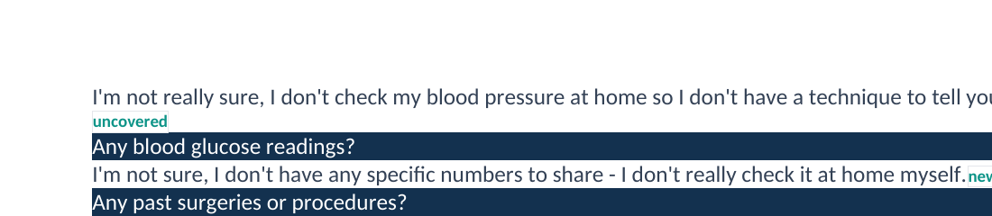
Evidence – Wednesday interview states no home glucose numbers and no routine self-monitoring.
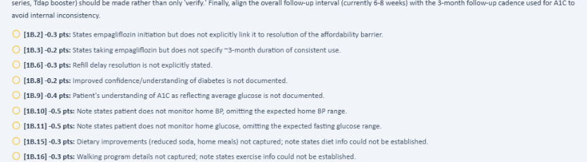
Grader evidence – Grader expects home BP/glucose monitoring data and fasting glucose information.

Issue 5. Exact disease durations are graded even though the AI patient cannot provide them
What the student saw or heard: James was separately asked how long he had diabetes, hypertension, and high cholesterol. He repeatedly stated that he could not remember the exact number of years or provide a specific timeframe.
What the grader expected: The grader deducts because diabetes, hypertension, and high cholesterol durations are documented as unknown rather than the exact hidden values expected by the rubric.
Why this is a problem: The student attempted to obtain the information directly, but the AI patient did not provide the exact values used for grading. Exact previous durations should not be hidden if they remain required at follow-up.
Suggested fix: Add a structured “duration” field to the follow-up problem list and/or have the AI patient consistently return the required durations when asked.
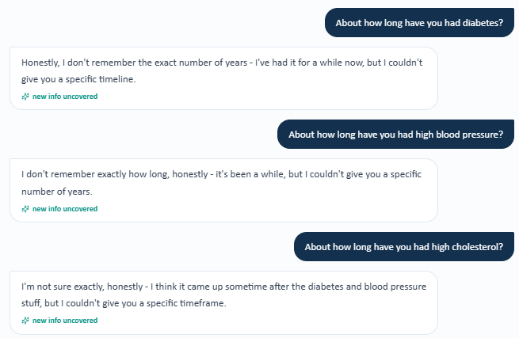
Evidence – James cannot provide exact durations for diabetes, hypertension, or high cholesterol.
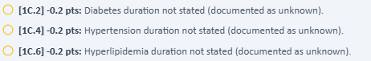
Grader evidence – Exact disease durations are required by the grader.

Issue 6. Lifestyle and walking-program details required by grader are not available from the AI patient
What the student saw or heard: James was asked multiple times about diet, daily intake, activity, exercise, and whether he was in a walking program. He could not provide a detailed diet, said he did not recall a particular exercise routine, and specifically said he was not really in a walking program.
What the grader expected: The grader expects reduced sugary-beverage intake, increased home meal preparation, and a walking program approximately 3 times weekly for 15–20 minutes. It also deducts later assessment/plan points for not attributing improvement to those lifestyle changes or continuing them.
Why this is a problem: These are specific positive lifestyle findings that the AI patient did not disclose despite direct probing. The student should not fabricate a walking program or diet changes that the AI patient says it cannot describe.
Suggested fix: Ensure all lifestyle findings used by the rubric are available through direct interview questions, or remove hidden scripted lifestyle details from grading. Follow-up cases should carry forward visible lifestyle trends when they are expected to support “improved” assessments.
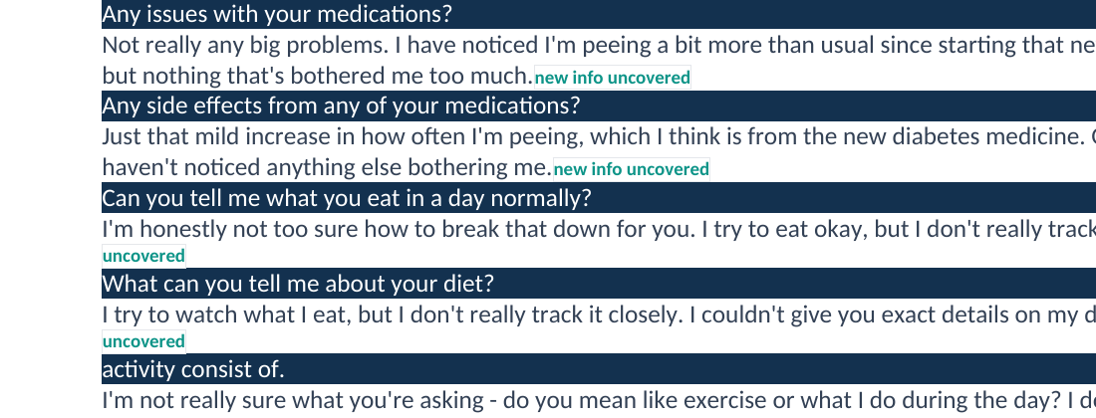
Evidence – Repeated diet/activity questioning does not yield the specific lifestyle improvements expected by the grader.
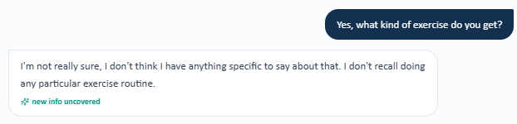
Evidence – James cannot identify a specific exercise routine.

Evidence – Direct walking-program question is answered negatively.
Grader evidence – Grader requires walking-program details.

Issue 7. Occupation and marital/living status are graded but the AI patient cannot provide them
What the student saw or heard: James was asked about work/occupation, living situation, and marital status. He repeatedly stated that he did not have specific information to provide. He did confirm that he independently manages his medications and daily activities.
What the grader expected: The grader deducts because marital/living status and occupation/retirement status were not established.
Why this is a problem: The student directly asked the relevant social-history questions, but the AI patient could not provide the details required by the grader/rubric.
Suggested fix: If occupation/retirement and marital/living status are required follow-up fields, expose them in the previous chart or ensure the AI patient answers them consistently when asked.
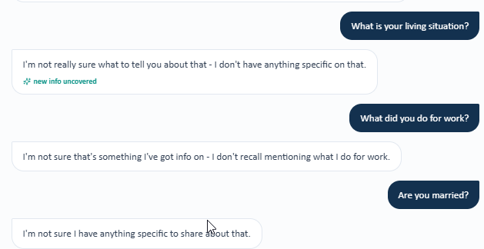
Evidence – AI patient cannot provide living, occupation, or marital-status specifics.

Grader evidence – Grader deducts for the unavailable social-history fields.

Issue 8. Preventive-care status is hidden: the EMR immunization panel is blank and the AI patient is unsure
What the student saw or heard: The Wednesday Objective view shows an Immunizations section without visible vaccine-status entries. When James was directly asked about influenza, COVID-19, pneumococcal, Shingrix, and Tdap history, he said he was unsure and did not have specifics.
What the grader expected: The grader expects influenza and COVID-19 to be confirmed current, pneumococcal and recombinant-zoster gaps to be identified, and the Tdap interval to be documented as 12 years. It then deducts additional assessment/plan points for not acting on those hidden gaps.
Why this is a problem: The required preventive-care facts are not displayed in the visible immunization panel and are not available from the AI patient. The student cannot confidently classify a vaccine as current, missing, or 12 years overdue without a source.
Suggested fix: Populate the visible immunization panel with the same statuses used by the grader, or make the AI patient return those statuses when asked. Downstream vaccine-plan grading should depend only on data that are actually available to the student.
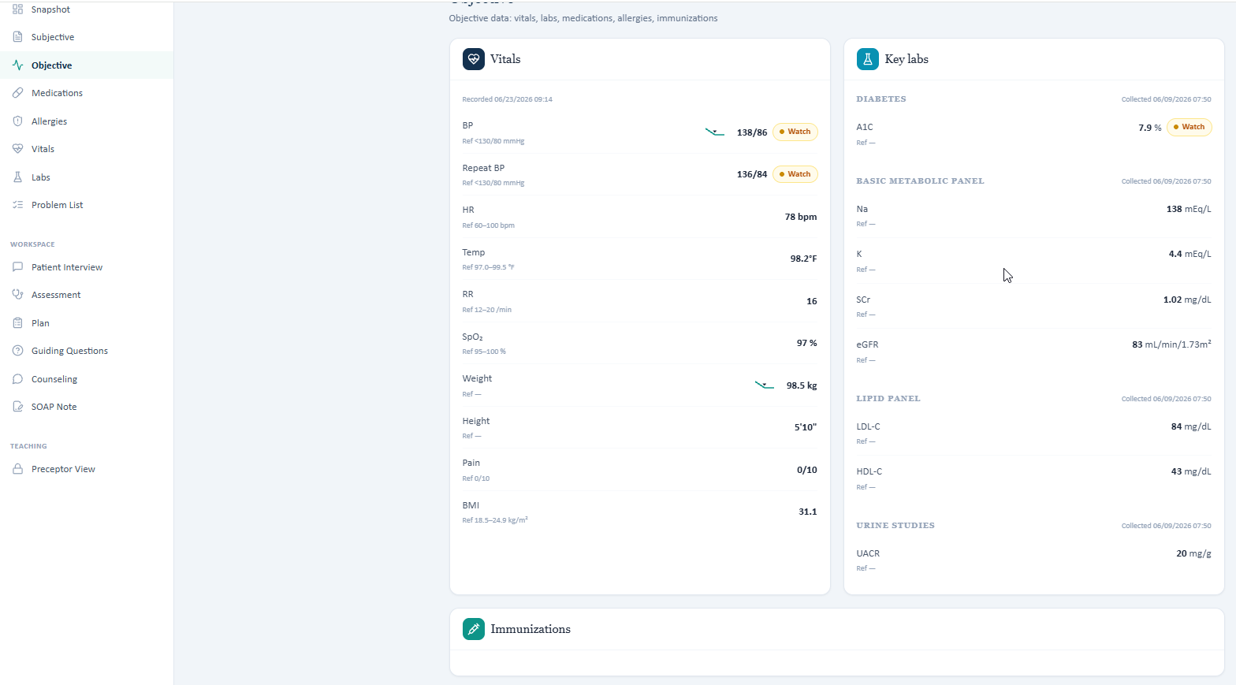
Evidence – Wednesday Objective view shows a blank Immunizations panel.
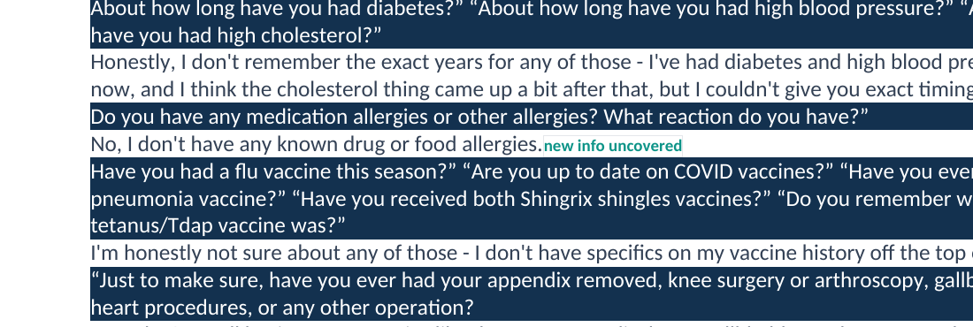
Evidence – Direct vaccine-history questioning yields uncertainty rather than the statuses required by the grader.
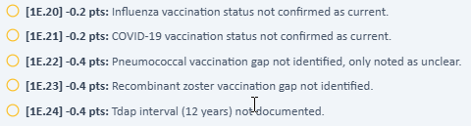
Grader evidence – Grader expects specific current/gap statuses and a 12-year Tdap interval.

Issue 9. Total cholesterol 178 mg/dL is graded but absent from the visible laboratory panel
What the student saw or heard: The Wednesday “All Labs” panel displays A1C, sodium, potassium, serum creatinine, eGFR, UACR, LDL-C, HDL-C, and triglycerides. No total cholesterol value appears in the visible laboratory panel.
What the grader expected: The grader deducts because total cholesterol 178 mg/dL was not reported.
Why this is a problem: A graded numeric laboratory value should be present in the visible source. The student cannot accurately transcribe a value that is omitted from the visible lab panel.
Suggested fix: Add total cholesterol 178 mg/dL to the visible lipid panel if it is part of the grader/rubric, or remove the hidden numeric requirement.
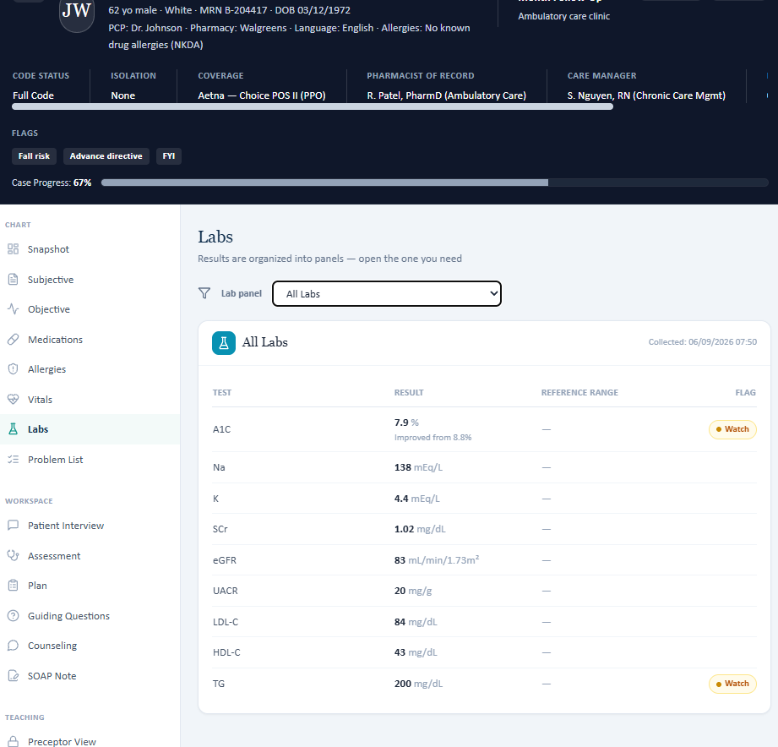
Evidence – Visible Wednesday laboratory panel contains LDL-C, HDL-C, and TG but no total cholesterol.
Grader evidence – Grader requires total cholesterol 178 mg/dL.

Patient B – James Wilson – Thursday 6-Month Follow-Up
9 confirmed system/data issues are included for this visit. Items are grouped so one underlying problem is not counted multiple times just because it caused several grader deductions.
# | Issue | Problem type
1 | Home blood pressure monitoring, range, and average required by the grader directly contradict the Thursday AI patient | AI patient and grader disagree
2 | Regular fasting-glucose monitoring and 120–140 mg/dL readings required by the grader directly contradict the Thursday AI patient | AI patient and grader disagree
3 | Increased home-prepared meals are graded as a required previous improvement but cannot be established from the Thursday AI patient | Required information is unavailable
4 | Exact chronic-disease durations remain required by the Thursday rubric but are not available from the AI patient | Required information is unavailable
5 | Appendectomy and knee arthroscopy required by the grader/rubric are directly denied by the Thursday AI patient | AI patient and grader disagree
6 | Recently retired truck-driver history is required by the grader but not available from the Thursday AI patient | Required information is unavailable
7 | Former-smoking and 20-pack-year history remain a direct contradiction between the Thursday AI patient and grader/rubric | AI patient and grader disagree
8 | Vaccine status and the 12-year Tdap interval are graded but unavailable in the Thursday visible data | Required information is unavailable
9 | Total cholesterol, HDL-C, and triglycerides are required by the grader but absent from the Thursday visible lipid panel | Required information is unavailable

Issue 1. Home blood pressure monitoring, range, and average required by the grader directly contradict the Thursday AI patient
What the student saw or heard: James reports that he does not check blood pressure regularly at home, usually knows his BP only from clinic visits, has no readings to share, and cannot provide a home average.
What the grader expected: The Thursday grader expects home BP checks several times weekly, a range in the 120s/70s, and a home log average of approximately 126/78 mmHg.
Why this is a problem: The student cannot accurately document a home BP range or average that the AI patient explicitly says he does not have. This single contradiction cascades into multiple subjective, objective, assessment, and plan deductions.
Suggested fix: Synchronize the AI-patient home BP history with the grader/rubric. If several-times-weekly monitoring and a 126/78 average are required, those data should be available when the patient is asked about frequency, readings, and average.
Evidence – Thursday patient interview: James says he does not check BP regularly and cannot provide readings or an average.
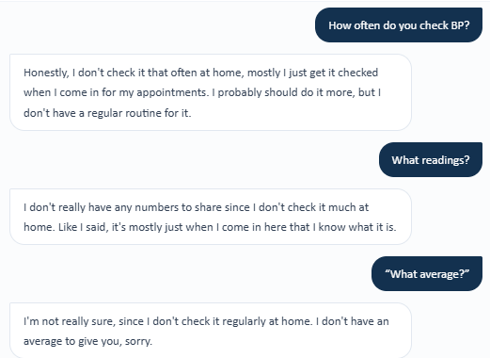

Issue 2. Regular fasting-glucose monitoring and 120–140 mg/dL readings required by the grader directly contradict the Thursday AI patient
What the student saw or heard: James states that he does not have a set home fasting-glucose routine, does not check often, and cannot provide specific home readings.
What the grader expected: The grader expects regular fasting-glucose checks with values approximately 120–140 mg/dL.
Why this is a problem: The SOAP note correctly preserves the AI patient’s statements. Adding a regular monitoring routine or numeric range would require inventing data not supplied by the patient.
Suggested fix: Align the AI patient with the grader/rubric so regular glucose monitoring and the expected fasting range are disclosed when directly asked.
Evidence – Thursday patient interview: James cannot provide a fasting-glucose monitoring frequency or readings.
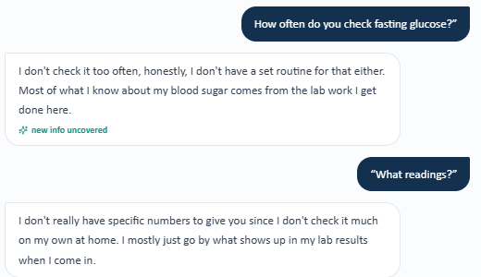
Grader Evidence B-TH1/B-TH2 – Grader expects regular home BP and glucose monitoring plus numeric ranges.
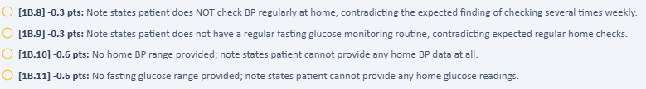

Issue 3. Increased home-prepared meals are graded as a required previous improvement but cannot be established from the Thursday AI patient
What the student saw or heard: When asked how often meals are prepared at home, James says he does not know the frequency and cannot recall how often they cook versus eat out.
What the grader expected: The grader expects increased home-prepared meals as a sustained lifestyle improvement.
Why this is a problem: A previous improvement cannot be documented when the AI patient cannot provide either the current frequency or a comparison with baseline.
Suggested fix: Persist the intended dietary-history change across follow-up visits and make it available with a direct question about home meal preparation.
Evidence – Thursday patient interview: frequency of home-prepared meals cannot be established.
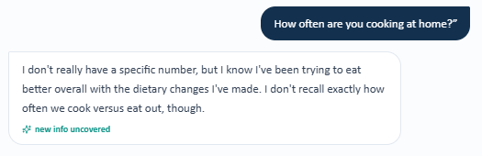
Grader evidence – Grader deducts because increased home-prepared meals were not documented.

Issue 4. Exact chronic-disease durations remain required by the Thursday rubric but are not available from the AI patient
What the student saw or heard: James is asked separately how long he has had diabetes, hypertension, and high cholesterol. He says he cannot remember the exact diagnosis timing for any of the three conditions.
What the grader expected: The grader expects type 2 diabetes for 10 years, hypertension for 12 years, and high cholesterol for 8 years.
Why this is a problem: These are hidden previous facts. The student asked the exact rubric-aligned questions but the AI patient could not provide the required values.
Suggested fix: Make exact durations available through the patient interview or a visible previous history section whenever exact durations are graded.
Evidence – Thursday patient interview: exact type 2 diabetes, high blood pressure, and high cholesterol durations are unavailable.
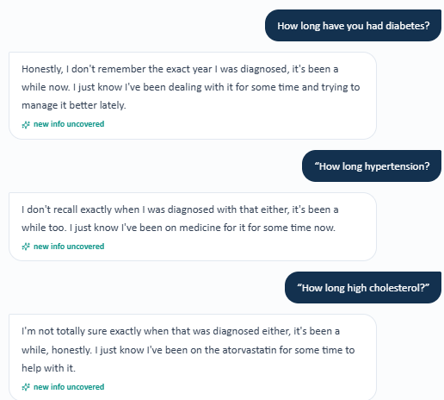
Grader evidence – Grader expects 10-, 12-, and 8-year durations.
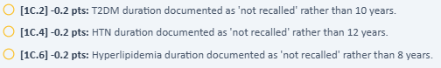

Issue 5. Appendectomy and knee arthroscopy required by the grader/rubric are directly denied by the Thursday AI patient
What the student saw or heard: James is specifically asked about appendix surgery and knee arthroscopy. He denies both and states that he does not recall having surgeries like those.
What the grader expected: The grader expects appendectomy at age 19 and right knee arthroscopy at age 51.
Why this is a problem: This is a direct contradiction after the exact procedures were named in the question. The student cannot safely document surgeries the AI patient explicitly denies.
Suggested fix: Synchronize surgical history between the AI patient and grader/rubric so the required procedures are disclosed when directly queried.
Evidence – Thursday patient interview: James denies appendix surgery and knee arthroscopy.
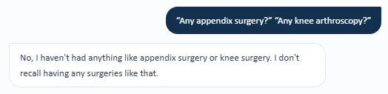
Grader evidence – Grader requires appendectomy age 19 and right knee arthroscopy age 51.

Issue 6. Recently retired truck-driver history is required by the grader but not available from the Thursday AI patient
What the student saw or heard: When asked what he did before retirement, James says he does not recall the details and has little information to share.
What the grader expected: The rubric expects “recently retired truck driver.”
Why this is a problem: The occupation/retirement fact is graded as known history, but a direct question does not provide it from the AI patient.
Suggested fix: Persist occupation/retirement history across visits and return it when the patient is directly asked about prior work.
Evidence – Thursday patient interview: prior occupation cannot be recalled.
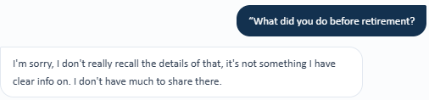
Grader evidence – Grader expects recently retired truck driver.

Issue 7. Former-smoking and 20-pack-year history remain a direct contradiction between the Thursday AI patient and grader/rubric
What the student saw or heard: James is directly asked whether he has ever smoked, the number of pack-years, and when he quit. He states that he has never smoked or used tobacco products and therefore has no pack-years or quit date.
What the grader expected: The grader expects former-smoker status, quit 10 years ago, with a 20-pack-year history.
Why this is a problem: The hidden expected history is the opposite of the AI patient’s explicit answer and can materially affect heart/vascular disease risk characterization.
Suggested fix: Synchronize tobacco history across the AI patient and grading rubric, including former status, quit timing, and pack-year exposure.
Evidence – Thursday patient interview: James states he has never smoked and has no pack-year or quit history.
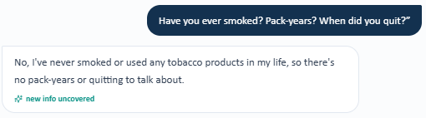
Grader evidence – Grader expects former smoker, quit 10 years ago, 20 pack-years.

Issue 8. Vaccine status and the 12-year Tdap interval are graded but unavailable in the Thursday visible data
What the student saw or heard: The Thursday Objective screen contains an Immunizations section but no vaccine entries or statuses are displayed. The patient also cannot recall detailed vaccine history.
What the grader expected: The grader expects influenza current, COVID-19 current, pneumococcal none on record, RZV/Shingrix none on record, and Tdap last documented 12 years ago.
Why this is a problem: Exact preventive-care status cannot be reliably documented from a blank visible immunization panel plus patient uncertainty, yet the grader requires those exact facts.
Suggested fix: Populate the visible immunization section with the vaccine statuses/intervals used by the rubric, or make those facts reliably available through the AI patient.
Evidence – Thursday Objective screen: immunization section is present but contains no vaccine-status entries.
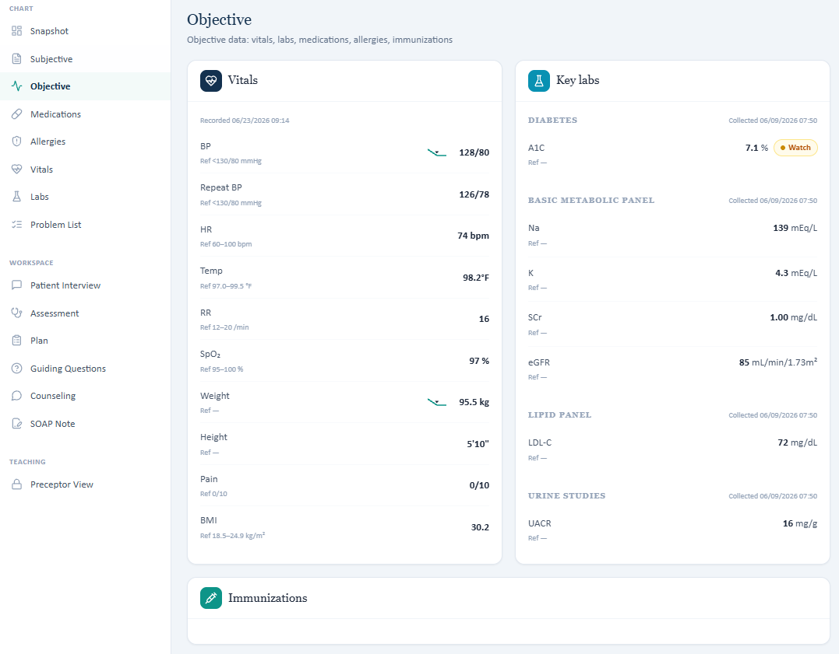
Grader evidence – Grader expects specific influenza, COVID, pneumococcal, RZV, and Tdap status.
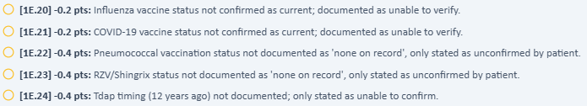

Issue 9. Total cholesterol, HDL-C, and triglycerides are required by the grader but absent from the Thursday visible lipid panel
What the student saw or heard: The Thursday Lipid Panel displays LDL-C 72 mg/dL only. It does not display total cholesterol, HDL-C, or triglycerides.
What the grader expected: The grader expects total cholesterol 165 mg/dL, HDL-C 44 mg/dL, and triglycerides 170 mg/dL in addition to LDL-C.
Why this is a problem: These are objective laboratory values that cannot be obtained from the visible Thursday lipid panel. Supplying them would require using hidden data.
Suggested fix: Display all lipid components required by the grading rubric in the visible lab panel or remove exact hidden values from the grading criteria.
Evidence – Thursday visible Lipid Panel: only LDL-C 72 mg/dL is displayed.
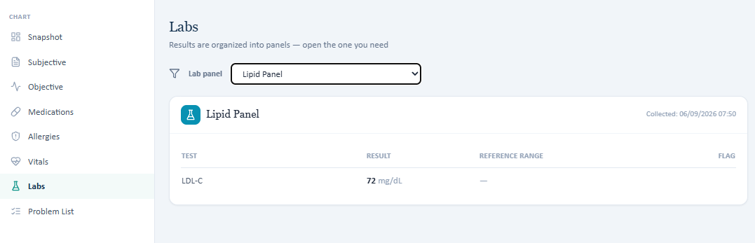
Grader evidence – Grader requires hidden total cholesterol, HDL-C, and triglyceride values.
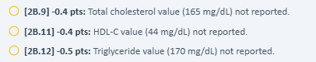

Patient C – Linda Martinez – Tuesday Initial Visit
12 confirmed system/data issues are included for this visit. Items are grouped so one underlying problem is not counted multiple times just because it caused several grader deductions.
# | Issue | Problem type
1 | Heart stent (PCI/DES) history is required by the grader/rubric but cannot be confirmed from the Tuesday AI patient | Required information is unavailable
2 | Expected positional leg swelling directly contradicts the Tuesday AI patient’s repeated denial | AI patient and grader disagree
3 | Home glucose monitoring frequency and fasting range required by the grader are not available from the Tuesday AI patient | Required information is unavailable
4 | Home BP monitoring frequency, range, and average are graded as required but unavailable from the Tuesday AI patient | Required information is unavailable
5 | Exact type 2 diabetes and hypertension durations are required by the rubric but cannot be obtained from the AI patient | Required information is unavailable
6 | Gallbladder removal (gallbladder removal (cholecystectomy)) and hysterectomy required by the grader/rubric are directly denied by the Tuesday AI patient | AI patient and grader disagree
7 | Marital/living status is graded as a required positive fact even though the AI patient declines to provide it | Data / grading mismatch
8 | Grandchildren childcare role is graded but the AI patient declines to discuss it | AI patient and grader disagree
9 | Influenza, COVID-19, pneumococcal, Shingrix, and Tdap details are graded but not reliably available | Required information is unavailable
10 | Prior UACR 410 mg/g and the 410→452 worsening trend are required by the grader but not exposed in the Tuesday visible labs | Required information is unavailable
11 | Total cholesterol 176 mg/dL is required by the grader but absent from the visible Tuesday laboratory panel | EMR and grader disagree
12 | Penicillin allergy reported by the AI patient conflicts with NKDA displayed in the EMR | Safety / chart conflict

Issue 1. Heart stent (PCI/DES) history is required by the grader/rubric but cannot be confirmed from the Tuesday AI patient
What the student saw or heard: Linda reports a myocardial infarction about three years ago, but when specifically asked about heart catheterization, stent placement, and stent type, she repeatedly states that she cannot remember the procedure details and that her records would need to be checked.
What the grader expected: The grader expects the prior STEMI to be documented with PCI and drug-eluting stent placement and deducts when the SOAP note preserves the patient’s uncertainty.
Why this is a problem: The interview directly probes the exact procedural details required by the rubric. The student cannot safely document PCI/DES when the AI patient cannot confirm it and the visible encounter does not expose the procedure details.
Suggested fix: Synchronize the AI-patient memory and visible history with the grader/rubric. If PCI/DES is required, it should be available when directly asked or visible in the follow-up/history data.
Evidence – Patient interview: Linda cannot confirm catheterization, stent placement, or stent type after her prior MI.
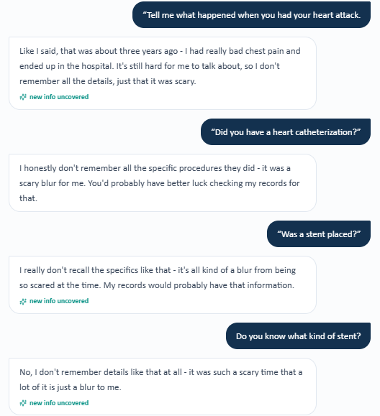
Grader evidence – Grader requires PCI/DES context despite the patient’s inability to recall it.

Issue 2. Expected positional leg swelling directly contradicts the Tuesday AI patient’s repeated denial
What the student saw or heard: Linda is asked whether her legs or feet ever swell and then specifically whether she develops mild swelling after standing for a long time. She denies swelling both generally and after prolonged standing.
What the grader expected: The grader expects occasional mild leg swelling after prolonged standing and deducts because the SOAP note documents the patient’s explicit denial.
Why this is a problem: This is a direct positive-versus-negative contradiction after a targeted follow-up question designed around the rubric criterion.
Suggested fix: Synchronize the AI patient with the grader/rubric. If positional edema is intended as a case fact, Linda should disclose it when asked directly about swelling after prolonged standing.
Evidence – Patient interview: Linda twice denies leg swelling, including after prolonged standing.
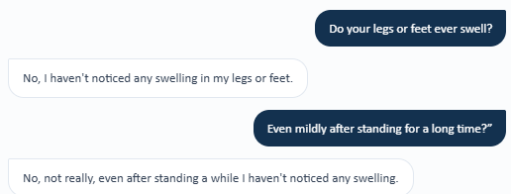
Grader evidence – Grader expects a positive positional-edema finding.

Issue 3. Home glucose monitoring frequency and fasting range required by the grader are not available from the Tuesday AI patient
What the student saw or heard: Linda states that she is not consistent about checking glucose at home, cannot remember how often she checks, and cannot provide specific fasting glucose readings.
What the grader expected: The grader expects glucose monitoring several times weekly and a fasting glucose range of 150–180 mg/dL.
Why this is a problem: The student asked both the frequency and exact readings. The AI patient did not provide the graded facts, so inserting the hidden frequency/range would require fabrication.
Suggested fix: Make the required monitoring frequency and fasting range available to the AI patient when asked, or remove those exact values from scoring if they are not intended to be discoverable.
Evidence – Patient interview: Linda cannot provide glucose-monitoring frequency or fasting readings.
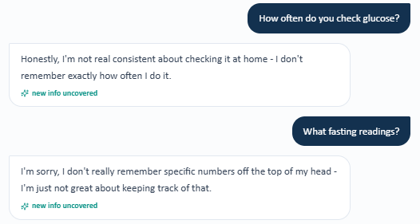
Grader evidence – Grader requires specific BP/glucose monitoring data that were not returned by the AI patient.
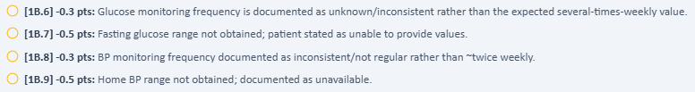

Issue 4. Home BP monitoring frequency, range, and average are graded as required but unavailable from the Tuesday AI patient
What the student saw or heard: Linda says she does not check BP very regularly at home, mostly learns values during appointments, and cannot provide a usual home range or average.
What the grader expected: The grader expects approximately twice-weekly monitoring, a high-130s/low-80s range, and a home BP log average around 138/82 mmHg.
Why this is a problem: The interview directly asks monitoring frequency, typical readings, and average. None of the required values are available, yet the grader deducts multiple times for their absence.
Suggested fix: Synchronize the AI patient/home-monitoring history with the grader/rubric or expose the home BP log in the visible EMR when exact home values are graded.
Evidence – Patient interview: Linda cannot provide home BP frequency, range, or average.
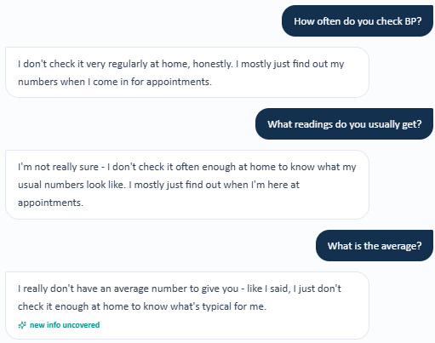
Grader evidence – Grader expects twice-weekly monitoring and a home BP range.

Grader evidence – Grader separately requires the hidden home BP average of ~138/82 mmHg.

Issue 5. Exact type 2 diabetes and hypertension durations are required by the rubric but cannot be obtained from the AI patient
What the student saw or heard: Linda is directly asked how long she has had diabetes and hypertension. She says she does not remember the exact year or number of years for either condition.
What the grader expected: The grader expects type 2 diabetes duration of 15 years and hypertension duration of 18 years.
Why this is a problem: The student targeted the exact duration criteria but the AI patient could not supply them. The hidden durations should not be inferred or invented.
Suggested fix: Persist exact chronic-disease durations in the AI patient or display them in the visible previous history whenever the rubric scores exact years.
Evidence – Patient interview: Linda cannot provide exact diabetes or hypertension durations.
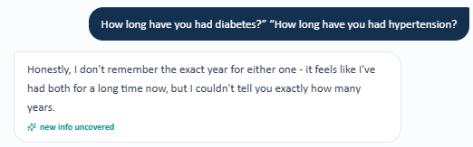
Grader evidence – Grader requires 15-year type 2 diabetes and 18-year high blood pressure durations.


Issue 6. Gallbladder removal (gallbladder removal (cholecystectomy)) and hysterectomy required by the grader/rubric are directly denied by the Tuesday AI patient
What the student saw or heard: Linda is specifically asked about gallbladder surgery, hysterectomy, other surgeries, and ages at surgery. She denies gallbladder surgery and hysterectomy and says she does not recall any surgeries.
What the grader expected: The grader expects gallbladder removal (cholecystectomy) and total abdominal hysterectomy and deducts because the SOAP note preserves the patient’s denial.
Why this is a problem: The exact procedures expected by the grader were named in the interview, making this a direct contradiction rather than an incomplete interview.
Suggested fix: Synchronize past surgical history across the AI patient and grader/rubric. Required surgeries should be disclosed when the student asks specifically about them.
Evidence – Patient interview: Linda explicitly denies gallbladder surgery, hysterectomy, and other surgery.
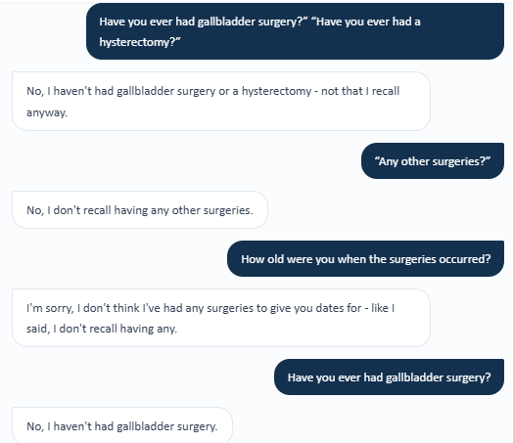
Grader evidence – Grader requires gallbladder removal (cholecystectomy) and hysterectomy despite the direct denials.

Issue 7. Marital/living status is graded as a required positive fact even though the AI patient declines to provide it
What the student saw or heard: When directly asked whether she is married and who she lives with, Linda declines to discuss the information and asks to focus on her health.
What the grader expected: The grader expects a specific marital/living status and deducts because the SOAP note correctly documents that the information was not obtained.
Why this is a problem: A student should not invent a spouse or household arrangement when a AI patient explicitly refuses to answer.
Suggested fix: Either allow the AI patient to provide the required marital/living fact when asked or adjust scoring so a documented patient refusal is not treated as a factual omission.
Evidence – Patient interview: Linda declines to provide marital and living-status information.
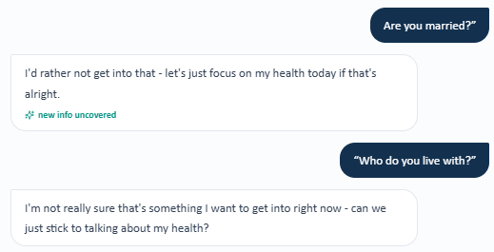
Grader evidence – Grader deducts because marital/living status was not obtained.


Issue 8. Grandchildren childcare role is graded but the AI patient declines to discuss it
What the student saw or heard: Linda is directly asked whether she helps take care of grandchildren and responds that she does not want to discuss that and would prefer to focus on her health.
What the grader expected: The grader expects a grandchildren/childcare role and deducts because it is absent from the note.
Why this is a problem: The fact is not available despite a direct rubric-aligned question. Documenting it anyway would contradict the patient’s stated refusal.
Suggested fix: If childcare is required for grading, the AI patient should disclose it when directly asked; otherwise a documented refusal should not be penalized as missing history.
Evidence – Patient interview: Linda declines to discuss grandchildren/childcare.

Grader evidence – Grader deducts for both living status and grandchildren/childcare data that the patient declined to provide.


Issue 9. Influenza, COVID-19, pneumococcal, Shingrix, and Tdap details are graded but not reliably available
What the student saw or heard: Linda reports that she does not keep good track of her vaccine history and cannot reliably recall current influenza/COVID status, pneumococcal details, Shingrix completion, or the timing of her last Tdap.
What the grader expected: The grader expects influenza current, COVID-19 current, pneumococcal vaccination details, completed Shingrix series, and Tdap 11 years ago, and deducts each item when the SOAP note preserves the uncertainty.
Why this is a problem: This is one underlying preventive-care data-availability problem generating multiple scoring deductions. A student cannot safely convert uncertain patient recall into specific vaccine dates/statuses.
Suggested fix: Expose the required immunization history in the visible EMR/immunization registry or make it available from the AI patient. Do not grade exact vaccine status/timing as hidden facts.
Grader evidence – Grader requires five specific immunization facts despite the patient’s inability to recall them.
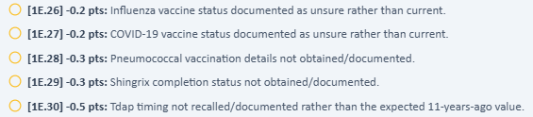

Issue 10. Prior UACR 410 mg/g and the 410→452 worsening trend are required by the grader but not exposed in the Tuesday visible labs
What the student saw or heard: The urine-studies panel shows the current UACR of 452 mg/g with severely increased albuminuria (A3). The visible visible data do not display a prior UACR of 410 mg/g or a numeric UACR trend.
What the grader expected: The grader requires prior UACR 410 mg/g and the exact worsening trend 410→452 mg/g.
Why this is a problem: The student can document the current severe albuminuria but cannot provide an exact prior value that is not visible. This is a hidden previous objective-data requirement.
Suggested fix: Display the prior UACR and trend in the visible follow-up/history view whenever the rubric requires those exact previous values.
Evidence – Student-facing urine studies: current UACR 452 mg/g is shown without the prior 410 mg/g value.
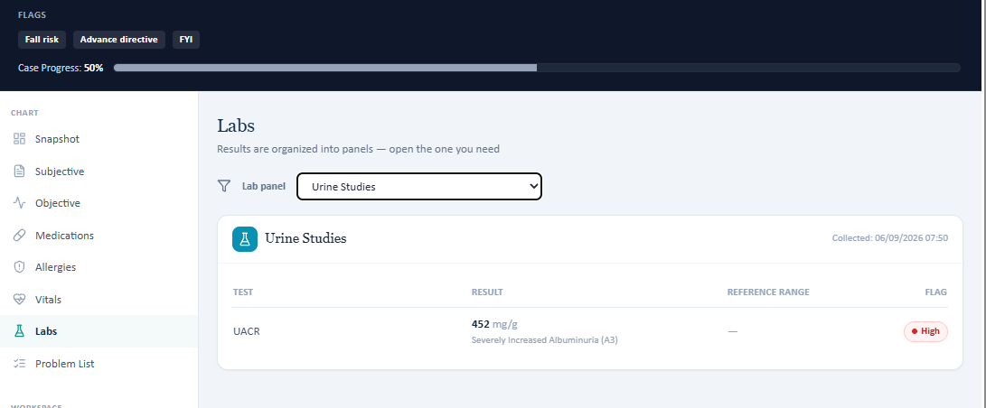
Grader evidence – Grader requires the hidden prior UACR and exact worsening trend.

Issue 11. Total cholesterol 176 mg/dL is required by the grader but absent from the visible Tuesday laboratory panel
What the student saw or heard: The visible All Labs panel shows A1C, sodium, potassium, serum creatinine, eGFR, UACR, LDL-C, HDL-C, and triglycerides, but no total cholesterol value.
What the grader expected: The grader expects total cholesterol 176 mg/dL and deducts because the SOAP note states that the value is not provided.
Why this is a problem: This is an objective-value exposure mismatch: the student is penalized for not reporting a number that the visible laboratory panel does not contain.
Suggested fix: Add total cholesterol to the visible lipid/lab panel when it is part of the grading rubric, or remove the exact value from scoring.
Evidence – Student-facing All Labs panel: LDL-C, HDL-C, and TG are visible, but total cholesterol is absent.
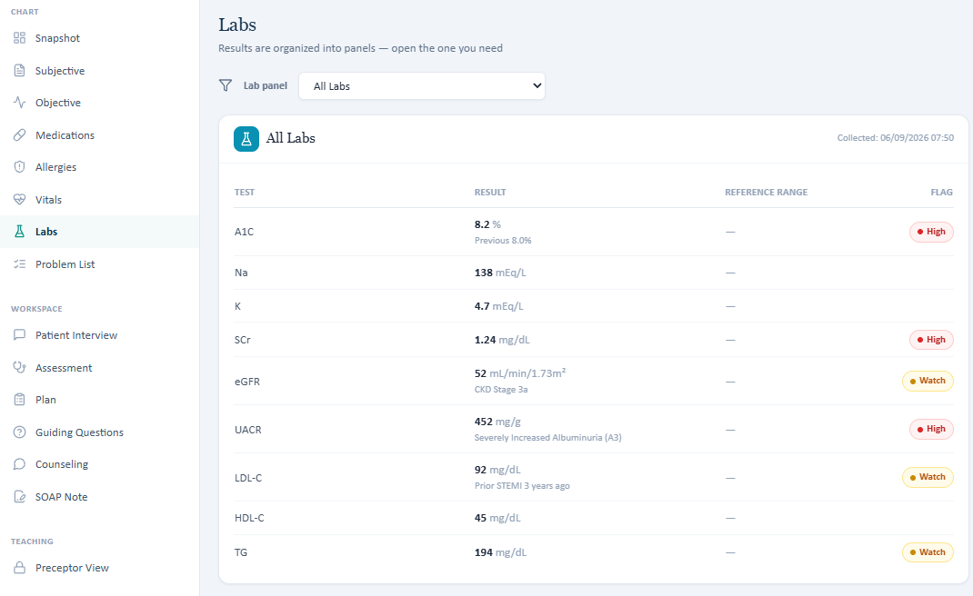
Grader evidence – Grader requires total cholesterol 176 mg/dL.

Issue 12. Penicillin allergy reported by the AI patient conflicts with NKDA displayed in the EMR
What the student saw or heard: Linda reports a penicillin allergy causing skin rash and hives as a child and says she was told the rash was severe. In contrast, the EMR header and drug-allergy table display “No known drug allergies (NKDA).”
What the grader expected: The grader did not deduct this item because the SOAP note captured the patient-reported allergy, but the underlying chart remains internally inconsistent.
Why this is a problem: This is a medication-safety and reconciliation issue independent of grader scoring. Different parts of the same encounter present conflicting allergy information.
Suggested fix: Reconcile the allergy record so the header, allergy table, and AI-patient history show one consistent verified allergy status. If the penicillin allergy is intended, remove NKDA and populate the reaction history.
Evidence – Patient interview: Linda reports penicillin-associated rash and hives in childhood.

Evidence – EMR allergy screen/header: the same encounter displays NKDA.
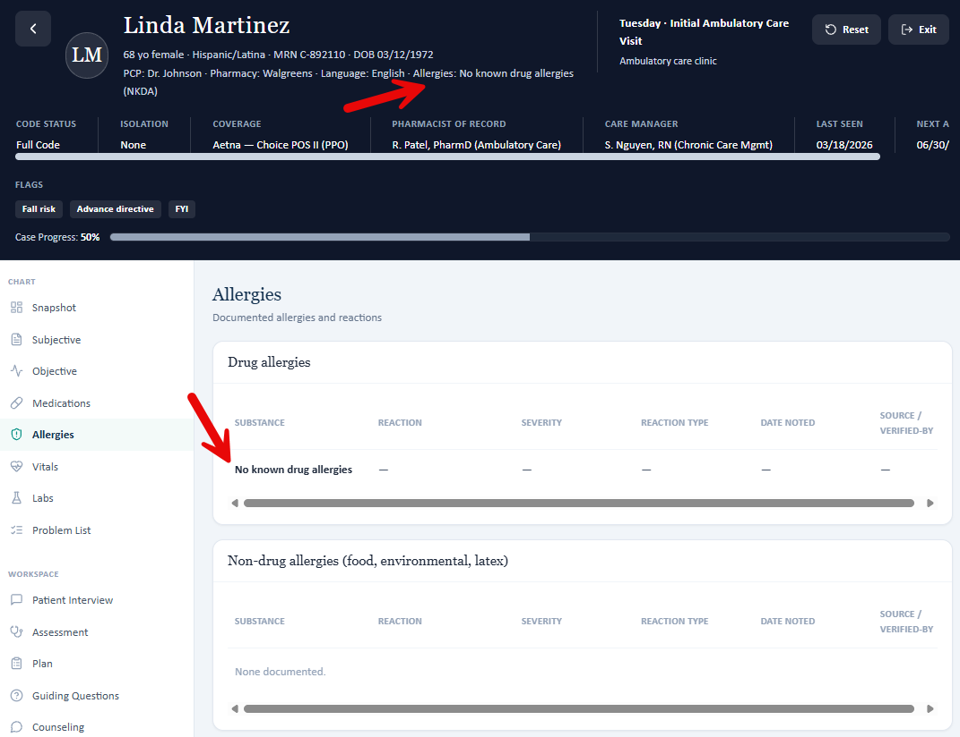

Patient C – Linda Martinez – Wednesday First Follow-Up
14 confirmed system/data issues are included for this visit. Items are grouped so one underlying problem is not counted multiple times just because it caused several grader deductions.
# | Issue | Problem type
1 | Heart stent (PCI/DES) history required by the grader is not available from the Wednesday AI patient | Required information is unavailable
2 | Grader expects 1–2 isolated missed doses, but the Wednesday AI patient reports no recent missed doses | AI patient and grader disagree
3 | Home BP monitoring frequency, range, and average are required by the grader but unavailable from the Wednesday AI patient | Required information is unavailable
4 | Home glucose monitoring frequency and fasting range are required by the grader but unavailable from the Wednesday AI patient | Required information is unavailable
5 | Specific dietary improvements required by the grader cannot be established from the Wednesday AI patient | Required information is unavailable
6 | Required increase in physical activity cannot be established or quantified from the Wednesday AI patient | Required information is unavailable
7 | Expected positional leg swelling and intermittent fatigue conflict with the Wednesday patient responses | AI patient and grader disagree
8 | Exact diabetes and hypertension durations remain required by the Wednesday rubric but are not available | Required information is unavailable
9 | Gallbladder removal (gallbladder removal (cholecystectomy)) and hysterectomy required by the grader cannot be established from the Wednesday AI patient | Required information is unavailable
10 | Living arrangement, occupation, and grandchildren/childcare role required by the rubric are not available | Required information is unavailable
11 | Vaccine status and Tdap timing are graded but unavailable in the Wednesday encounter | Required information is unavailable
12 | Multiple Wednesday objective values in the visible EMR disagree with the grader/rubric | EMR and grader disagree
13 | Total cholesterol, HDL-C, and triglycerides are required by the Wednesday grader but not displayed in the visible laboratory panel | Required information is unavailable
14 | Penicillin allergy reported by the Wednesday AI patient conflicts with NKDA displayed in the EMR | Safety / chart conflict

Issue 1. Heart stent (PCI/DES) history required by the grader is not available from the Wednesday AI patient
What the student saw or heard: Linda confirms a prior heart attack but, when directly asked whether a stent was placed, says she does not remember the details of what was done during the hospitalization.
What the grader expected: The Wednesday grader expects prior STEMI with PCI and drug-eluting stent context and deducts when PCI/stent status is documented as unconfirmed.
Why this is a problem: The student asked directly about the procedure and should not convert an uncertain patient response into a confirmed PCI/DES history. The required procedural fact is not reliably available from the AI patient.
Suggested fix: Persist the prior PCI/DES history in the AI patient or expose it in the visible cardiovascular/procedural history whenever the rubric requires it.
Evidence – Patient interview: Linda remembers the prior heart attack but cannot confirm whether a stent was placed.
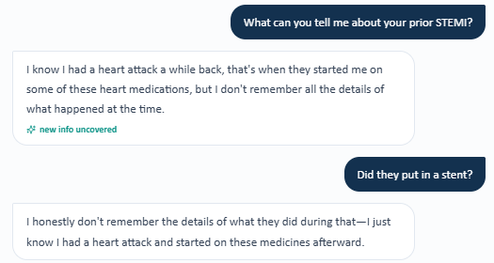
Grader evidence – Grader requires PCI/stent context despite the patient’s uncertainty.

Issue 2. Grader expects 1–2 isolated missed doses, but the Wednesday AI patient reports no recent missed doses
What the student saw or heard: When asked whether she ever misses doses, Linda says she has been good about taking everything as prescribed and has not been missing doses.
What the grader expected: The grader expects documentation of approximately 1–2 isolated missed doses and deducts because the note reports excellent adherence without those events.
Why this is a problem: This is a positive-versus-negative adherence-history mismatch. The SOAP note accurately reflects the patient’s direct answer, while the rubric expects a different previous fact.
Suggested fix: Synchronize the AI-patient adherence history with the grader/rubric so the same encounter returns a stable missed-dose history.
Evidence – Patient interview: Linda reports no recent missed doses.

Grader evidence – Grader expects detail on 1–2 isolated missed doses.

Issue 3. Home BP monitoring frequency, range, and average are required by the grader but unavailable from the Wednesday AI patient
What the student saw or heard: Linda states that she does not really keep track of BP at home and mostly has it checked at appointments. She cannot provide a home range, log, or reliable average.
What the grader expected: The rubric expects several-times-weekly home BP monitoring, an upper-120s/upper-70s range, and a home average around 129/78 mmHg. The grader also expects home BP to corroborate office control.
Why this is a problem: The interview directly asks about home monitoring, yet the exact graded values are not returned. The student cannot safely document a home log that the AI patient says is unavailable.
Suggested fix: Make the required home BP frequency/range/average available from the AI patient or display the home BP log in the visible follow-up EMR.
Evidence – Patient interview: Linda reports no regular home BP tracking and no home readings to report.
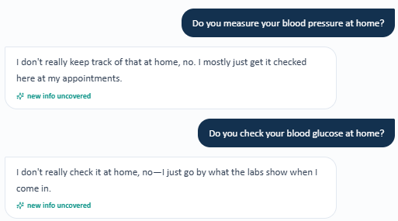
Grader evidence – Grader requires specific home BP and glucose monitoring data.
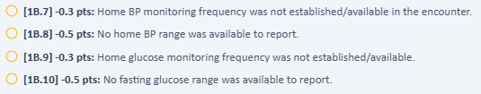

Issue 4. Home glucose monitoring frequency and fasting range are required by the grader but unavailable from the Wednesday AI patient
What the student saw or heard: Linda says she does not really check blood glucose at home and mainly relies on laboratory results when she comes to clinic. No fasting range is available.
What the grader expected: The Wednesday rubric expects glucose monitoring several times weekly and fasting readings of 130–160 mg/dL.
Why this is a problem: The patient directly denies having the graded home-monitoring pattern. Inserting the hidden range would make the SOAP note inconsistent with the interview.
Suggested fix: Synchronize the AI-patient glucose-monitoring history with the grader/rubric or expose the home glucose data elsewhere in the visible case.
Evidence – Same combined interview evidence above shows that Linda does not perform regular home glucose monitoring.

Grader evidence – Same grader evidence above requires home glucose frequency and fasting values.


Issue 5. Specific dietary improvements required by the grader cannot be established from the Wednesday AI patient
What the student saw or heard: Linda is directly asked how her diet has improved and whether she has reduced sodium intake. She says she has no specific diet or sodium details to share.
What the grader expected: The rubric expects reduced sodium, fewer restaurant meals, and improved portion control and deducts when these specific previous improvements are absent.
Why this is a problem: The rubric requires before/after lifestyle facts that the AI patient cannot reproduce when directly asked. The student should not invent specific diet changes.
Suggested fix: Persist the intended diet changes in the follow-up AI-patient state or remove those exact lifestyle facts from scoring when they are not available.
Evidence – Patient interview: no specific diet or sodium improvements can be provided.
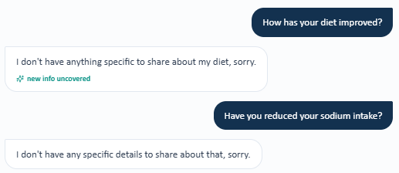
Grader evidence – Grader deducts because specific dietary improvements were not established.

Issue 6. Required increase in physical activity cannot be established or quantified from the Wednesday AI patient
What the student saw or heard: During the fresh Wednesday interview, Linda could not establish a specific walking/exercise program or quantify days per week and minutes per session.
What the grader expected: The rubric expects increased activity approximately 3–4 days/week for 20–30 minutes/session and later expects continuation of that walking program.
Why this is a problem: A “continue walking” plan presumes an existing program that the AI patient did not confirm. The student appropriately avoided fabricating an activity baseline.
Suggested fix: Make the intended activity program available from the AI patient if it is required for previous scoring, or score a newly initiated activity plan appropriately when no baseline program is available.
Grader evidence – Grader deducts for missing quantified physical-activity improvement and expected positional swelling.

Grader evidence – Grader also deducts for missing physical-activity frequency/duration in social history.
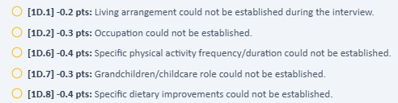

Issue 7. Expected positional leg swelling and intermittent fatigue conflict with the Wednesday patient responses
What the student saw or heard: Linda is directly asked whether she develops leg swelling after standing for a long time and says she has not noticed anything like that. In the same fresh interview, she also denies unusual fatigue.
What the grader expected: The grader/rubric expects occasional mild leg swelling after prolonged standing and intermittent fatigue. The grader deducts when the note preserves the negative symptom history.
Why this is a problem: These are direct positive-versus-negative symptom inconsistencies. The student cannot accurately document symptoms that the AI patient explicitly denies.
Suggested fix: Synchronize the AI-patient symptom state with the grader/rubric and keep it stable across direct follow-up questions.
Evidence – Patient interview: Linda denies leg swelling after prolonged standing.

Grader evidence – Grader expects positional leg swelling.


Issue 8. Exact diabetes and hypertension durations remain required by the Wednesday rubric but are not available
What the student saw or heard: Linda is asked how long she has had diabetes and hypertension and says she does not remember the exact timing for either diagnosis.
What the grader expected: The grader expects type 2 diabetes for 15 years and hypertension for 18 years.
Why this is a problem: The exact chronic-disease durations are hidden previous facts. The student targeted the criterion directly but the AI patient cannot supply the required years.
Suggested fix: Persist exact chronic-disease durations across follow-up visits or expose them in the previous problem history when they are rubric-scored.
Evidence – Patient interview: exact diabetes and hypertension durations cannot be recalled.
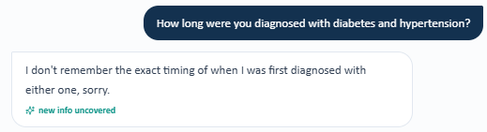
Grader evidence – Grader requires 15-year type 2 diabetes and 18-year high blood pressure durations.


Issue 9. Gallbladder removal (gallbladder removal (cholecystectomy)) and hysterectomy required by the grader cannot be established from the Wednesday AI patient
What the student saw or heard: When asked about past surgeries or procedures, Linda says nothing comes to mind. In the fresh interview she does not establish prior gallbladder surgery or hysterectomy.
What the grader expected: The rubric requires gallbladder removal (cholecystectomy) and total abdominal hysterectomy and deducts because those histories could not be recalled/established.
Why this is a problem: The required PSH is not available through direct questioning. The student should not convert an uncertain/negative surgical history into confirmed operations.
Suggested fix: Synchronize previous surgical history across the AI patient and rubric or expose the surgeries in the visible follow-up record.
Evidence – Patient interview: Linda cannot provide any past surgical/procedural history.

Grader evidence – Grader requires gallbladder removal (cholecystectomy) and hysterectomy.


Issue 10. Living arrangement, occupation, and grandchildren/childcare role required by the rubric are not available
What the student saw or heard: Linda is directly asked about her living situation, marital status, who she lives with, and what she did for work. She says she has no specific information to provide. The fresh interview likewise does not establish the rubric-required grandchildren/childcare role.
What the grader expected: The grader expects married/lives with husband, retired teacher, and a grandchildren/childcare role, and deducts when these previous social-history facts are absent.
Why this is a problem: These are specific previous facts that are not returned when the patient is directly questioned. The student should not fabricate them from a hidden key.
Suggested fix: Persist social-history facts across follow-up encounters or adjust scoring when the patient does not provide the information despite direct questioning.
Evidence – Patient interview: living arrangement and occupation cannot be established.
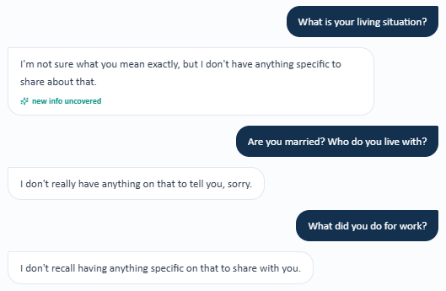
Grader evidence – Grader deducts for living arrangement, occupation, childcare role, and related unestablished lifestyle details.


Issue 11. Vaccine status and Tdap timing are graded but unavailable in the Wednesday encounter
What the student saw or heard: Linda cannot confirm influenza, COVID-19, pneumococcal, Shingrix, or Tdap history, and the Wednesday visible immunization section does not expose the exact rubric-required statuses/dates.
What the grader expected: The grader expects influenza current, COVID-19 current, pneumococcal vaccination history, Shingrix completion, and Tdap 11 years ago; it also treats Tdap as overdue.
Why this is a problem: Multiple preventive-care deductions arise from one underlying data-availability problem. The student cannot safely label vaccines current/complete or Tdap overdue without a available record.
Suggested fix: Expose the required vaccine history in the visible immunization module or make it available from the AI patient. Avoid penalizing verification language when the source data are absent.
Grader evidence – Grader requires five specific immunization facts that could not be confirmed in the encounter.
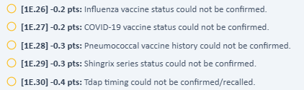

Issue 12. Multiple Wednesday objective values in the visible EMR disagree with the grader/rubric
What the student saw or heard: The Wednesday encounter displays BP 128/78 mmHg, repeat BP 126/76 mmHg, weight 94 kg, BMI 34.5 kg/m², sodium 139 mEq/L, and serum creatinine 1.26 mg/dL. These were transcribed into the SOAP note.
What the grader expected: The grader instead expects BP 130/78, repeat BP 128/78, weight 94.5 kg, BMI 34.7 kg/m², sodium 138 mEq/L, and serum creatinine 1.28 mg/dL and deducts for the visible EMR values.
Why this is a problem: These are direct objective-data mismatches between the visible encounter and the grader/rubric, not interview or documentation failures. Accurate transcription of the visible chart is penalized.
Suggested fix: Use one synchronized objective dataset for the student EMR and grader. When source values change, update the rubric/reference answer at the same time.
Objective mismatch summary: BP 128/78 → grader 130/78; repeat BP 126/76 → 128/78; weight 94 kg → 94.5 kg; BMI 34.5 → 34.7 kg/m²; sodium 139 → 138 mEq/L; SCr 1.26 → 1.28 mg/dL.
Evidence – Student-facing Wednesday labs: sodium 139 mEq/L and SCr 1.26 mg/dL are visibly displayed, along with the current A1C/UACR/LDL values.
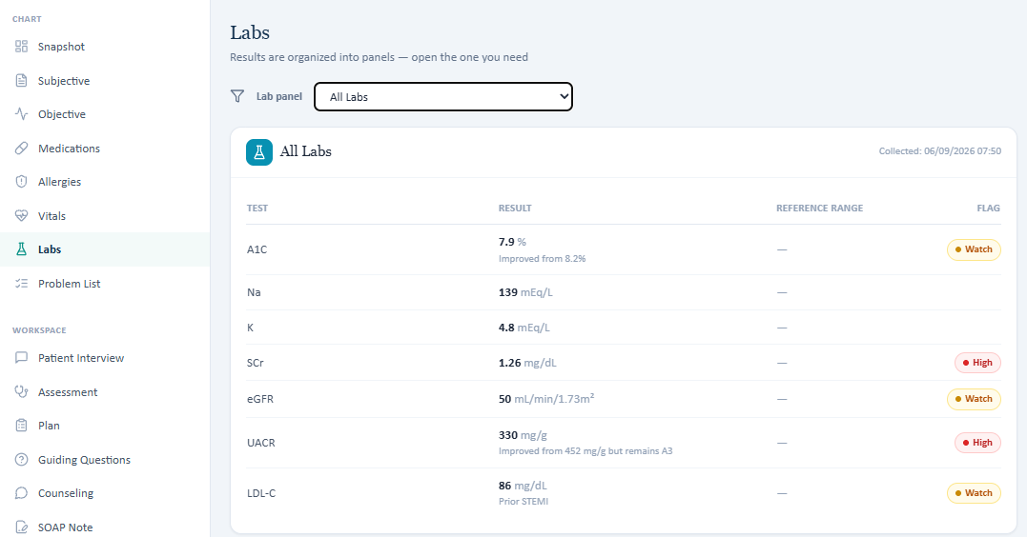
Grader evidence – Grader deducts for different expected BP, weight, BMI, sodium, and creatinine values.
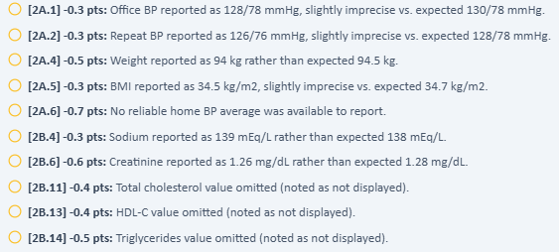

Issue 13. Total cholesterol, HDL-C, and triglycerides are required by the Wednesday grader but not displayed in the visible laboratory panel
What the student saw or heard: The visible Wednesday All Labs panel includes A1C, sodium, potassium, serum creatinine, eGFR, UACR, and LDL-C but does not display total cholesterol, HDL-C, or triglycerides.
What the grader expected: The rubric requires total cholesterol 170 mg/dL, HDL-C 45 mg/dL, and triglycerides 184 mg/dL and deducts when the SOAP note omits them.
Why this is a problem: The grader requires objective values that are not exposed to the student. Supplying them would require guessing or using hidden reference data.
Suggested fix: Display all rubric-scored lipid components in the visible lipid/lab panel or remove hidden values from the grading criteria.
Evidence – Student-facing Wednesday All Labs panel: only LDL-C is displayed from the lipid panel; total cholesterol, HDL-C, and TG are absent.

Grader evidence – Grader deducts for the three hidden lipid values.


Issue 14. Penicillin allergy reported by the Wednesday AI patient conflicts with NKDA displayed in the EMR
What the student saw or heard: Linda directly reports a bad penicillin-associated skin rash and hives in childhood and says her family described the reaction as severe. The Wednesday EMR header and allergy table simultaneously display No known drug allergies (NKDA).
What the grader expected: The SOAP note captures the patient-reported allergy, so this did not generate the major Wednesday point loss. The underlying chart, however, remains internally inconsistent.
Why this is a problem: Conflicting allergy documentation is a medication-safety and reconciliation defect independent of AI grading accuracy.
Suggested fix: Reconcile the allergy record so the AI patient, EMR header, and allergy table show one verified status and reaction.
Evidence – Patient interview: Linda reports penicillin-associated rash and hives.

Evidence – Wednesday EMR allergy screen/header: No known drug allergies (NKDA).
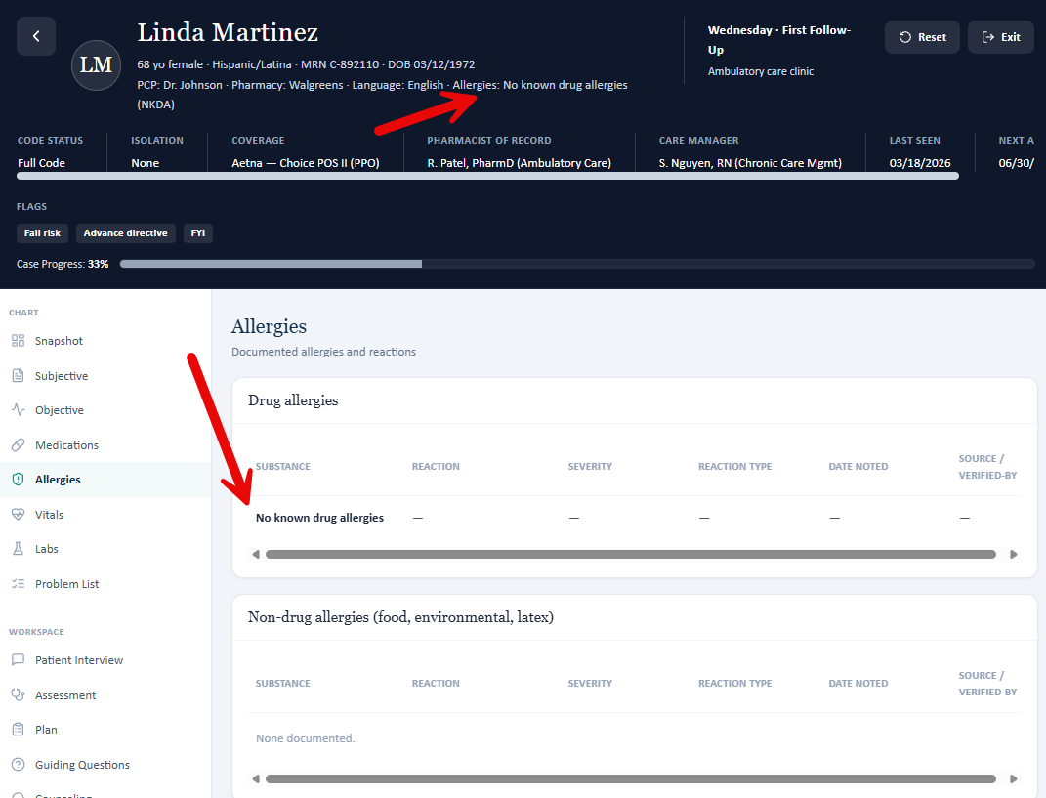

Patient C – Linda Martinez – Thursday Final Follow-Up
11 confirmed system/data issues are included for this visit. Items are grouped so one underlying problem is not counted multiple times just because it caused several grader deductions.
# | Issue | Problem type
1 | Current medication doses in the EMR and AI patient do not match the grader | AI patient and grader disagree
2 | Current A1C and LDL cholesterol values in the EMR do not match the grader | AI patient and grader disagree
3 | Home blood pressure and home glucose readings are required by the grader but denied by the AI patient | Data / grading mismatch
4 | Exercise and diet improvements required by the grader are not available from the AI patient | Required information is unavailable
5 | Exact diabetes and high blood pressure durations are required but not available from the AI patient | Required information is unavailable
6 | Prior heart attack timing and heart stent details are required but not available from the AI patient | Required information is unavailable
7 | Surgical history required by the grader conflicts with the AI patient | AI patient and grader disagree
8 | Living situation, work history, and childcare role are graded but not available from the AI patient | Required information is unavailable
9 | Vaccine history is graded but the Thursday EMR and AI patient do not provide the required details | Data / grading mismatch
10 | Additional historical and lipid laboratory values are required by the grader but are not shown in the Thursday lab panel | Data / grading mismatch
11 | Penicillin allergy reported by the AI patient conflicts with “No known drug allergies” in the EMR | Safety / chart conflict

Issue 1. Current medication doses in the EMR and AI patient do not match the grader
What the student saw or heard: The Thursday medication list and the AI patient both show semaglutide 0.5 mg once weekly and atorvastatin 40 mg once daily.
What the grader expected: The grader expects semaglutide 1 mg weekly and atorvastatin 80 mg daily, and it labels continuation of the lower doses as unsafe.
Why this is a problem: The student is penalized for copying the current medication list and the patient’s own medication report. This creates a medication-safety concern because the system gives two different “current” regimens.
Suggested fix: Synchronize the EMR medication list, AI patient, and grader before scoring. The grader should not label a dose as unsafe when that dose is the one shown in the student’s chart and confirmed by the AI patient.
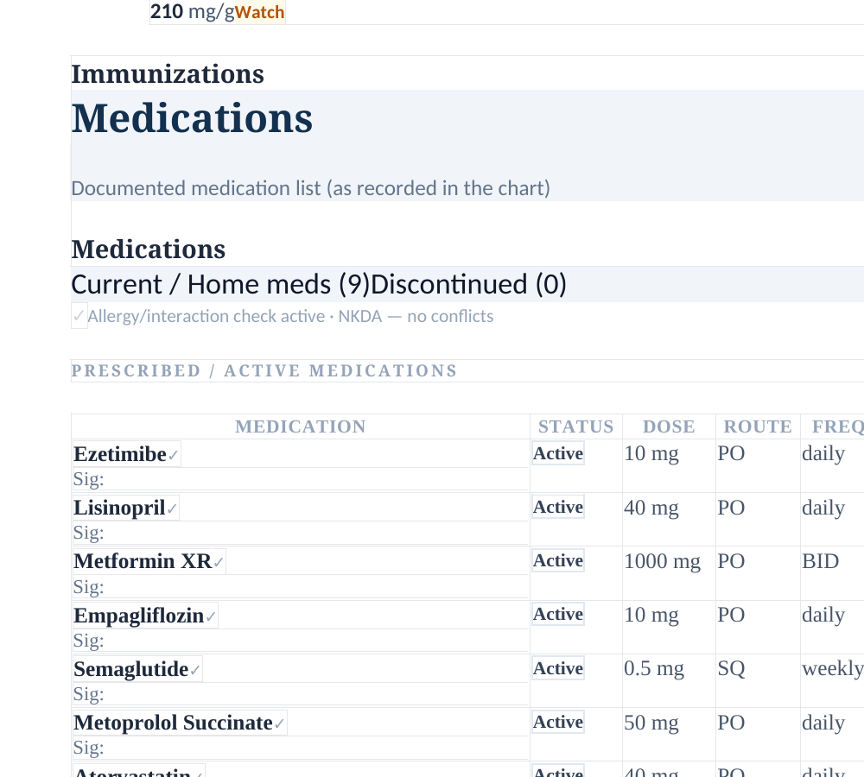
EMR evidence – the chart lists semaglutide 0.5 mg weekly and atorvastatin 40 mg daily.
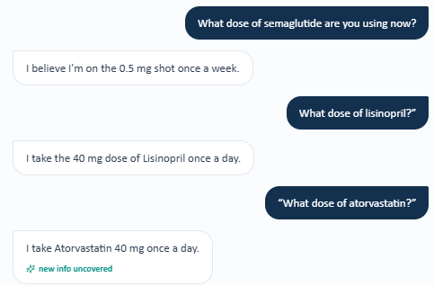
Interview evidence – Linda reports semaglutide 0.5 mg weekly and atorvastatin 40 mg daily.
Grader evidence – the grader expects semaglutide 1 mg weekly.
Grader evidence – the grader expects atorvastatin 80 mg daily.

Issue 2. Current A1C and LDL cholesterol values in the EMR do not match the grader
What the student saw or heard: The Thursday laboratory screen shows A1C 7.6% and LDL cholesterol 64 mg/dL.
What the grader expected: The grader expects A1C 7.2% and LDL cholesterol 63 mg/dL.
Why this is a problem: These are exact numeric values. The student should be able to copy what is shown in the chart without losing points for a different hidden value.
Suggested fix: Use the same laboratory dataset for the student EMR and the grader.
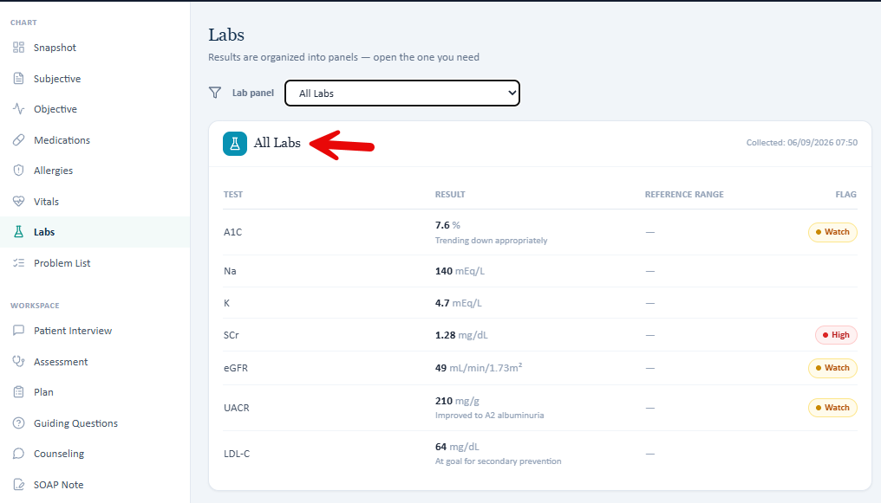
EMR evidence – current laboratory values shown to the student.
Grader evidence – A1C is scored against a different value.
Grader evidence – LDL cholesterol is scored against a different value.

Issue 3. Home blood pressure and home glucose readings are required by the grader but denied by the AI patient
What the student saw or heard: Linda says she does not check blood pressure or blood sugar at home and therefore has no home readings or average to report.
What the grader expected: The grader expects home blood pressure readings in the low 120s/mid-70s with an average around 123/75 mmHg, plus fasting glucose readings around 120–140 mg/dL.
Why this is a problem: The SOAP note cannot safely invent home readings after the AI patient says that no home monitoring is being done.
Suggested fix: Make the home readings available in the EMR or have the AI patient provide the same readings when asked. Otherwise, remove these hidden values from scoring.
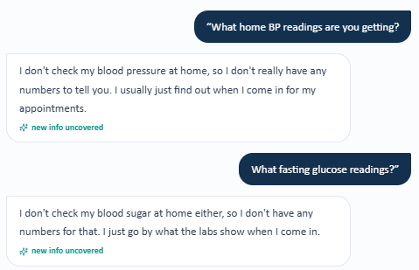
Interview evidence – Linda reports no home blood pressure or glucose readings.
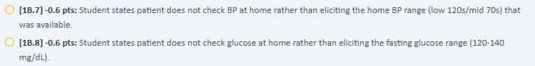
Grader evidence – home blood pressure and glucose values are expected.
Grader evidence – a home blood pressure average is also required.

Issue 4. Exercise and diet improvements required by the grader are not available from the AI patient
What the student saw or heard: Linda cannot give the number of walking days, minutes per session, exact sodium reduction, or specific portion-control and restaurant-meal changes.
What the grader expected: The grader expects walking about 5 days per week for 30–40 minutes and specific diet improvements such as reduced sodium and improved portion control.
Why this is a problem: The student asked the targeted questions, but the AI patient did not provide the details used by the grader.
Suggested fix: If these lifestyle details are graded, the AI patient should consistently provide them when directly asked.
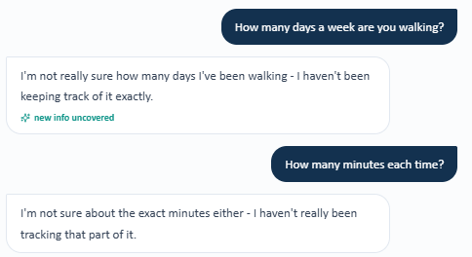
Interview evidence – walking frequency and duration cannot be quantified.
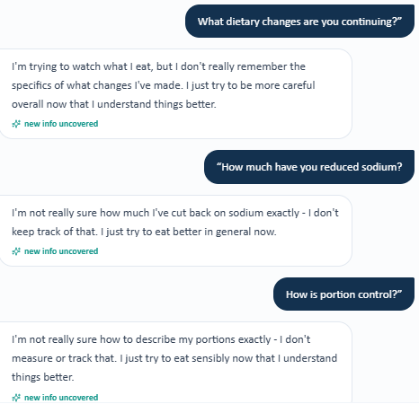
Interview evidence – specific diet changes cannot be quantified.
Grader evidence – a specific walking program is expected.
Grader evidence – specific diet changes are expected.

Issue 5. Exact diabetes and high blood pressure durations are required but not available from the AI patient
What the student saw or heard: Linda says she does not know the exact number of years she has had diabetes or high blood pressure.
What the grader expected: The grader expects 15 years of diabetes and 18 years of high blood pressure.
Why this is a problem: The student directly asked for the durations but did not receive the values used for grading.
Suggested fix: Expose the durations in the EMR or have the AI patient provide them consistently when asked.
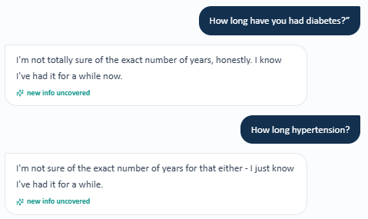
Interview evidence – Linda cannot provide exact disease durations.
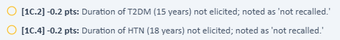
Grader evidence – exact 15-year and 18-year durations are required.

Issue 6. Prior heart attack timing and heart stent details are required but not available from the AI patient
What the student saw or heard: Linda remembers having a heart attack but cannot recall whether she had a stent or other procedure and cannot provide the details.
What the grader expected: The grader expects the heart attack to be documented as about 3 years ago and expects PCI/drug-eluting stent history.
Why this is a problem: The student should not invent a procedure or stent type that the AI patient cannot confirm.
Suggested fix: Put the heart attack timing and stent history in the visible chart or make the AI patient provide it when asked.
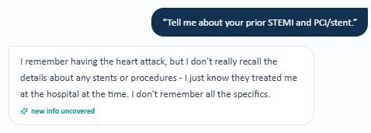
Interview evidence – Linda cannot provide the stent/procedure details.
Grader evidence – heart attack timing and PCI/DES details are expected.

Issue 7. Surgical history required by the grader conflicts with the AI patient
What the student saw or heard: Linda says she does not recall gallbladder surgery and explicitly says she has not had a hysterectomy.
What the grader expected: The grader expects a prior gallbladder removal (cholecystectomy) and hysterectomy and marks the hysterectomy denial as inaccurate.
Why this is a problem: The AI patient and grader are giving mutually exclusive surgical histories. The student cannot safely document both.
Suggested fix: Synchronize the AI patient’s surgical history with the grader and visible chart.

Interview evidence – Linda denies/does not recall the surgeries expected by the grader.
Grader evidence – gallbladder removal (cholecystectomy) and hysterectomy are required.

Issue 8. Living situation, work history, and childcare role are graded but not available from the AI patient
What the student saw or heard: Linda cannot provide who she lives with, what she did for work, or whether she helps care for grandchildren.
What the grader expected: The grading rubric expects married/living with husband, retired elementary-school teacher, and a regular grandchildren-care role.
Why this is a problem: These social-history details are being scored even though the AI patient does not provide them after direct questioning.
Suggested fix: If these facts are required, make them visible in the chart or reliably available from the AI patient.
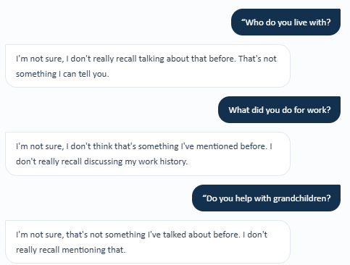
Interview evidence – living, work, and grandchildren details are unavailable.
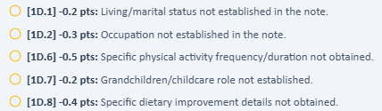
Grader evidence – those social-history details are required.

Issue 9. Vaccine history is graded but the Thursday EMR and AI patient do not provide the required details
What the student saw or heard: The visible Immunizations section is blank, and Linda says she cannot confirm influenza, COVID-19, pneumococcal, Shingrix, or Tdap history.
What the grader expected: The grader expects influenza, COVID-19, and pneumococcal vaccines to be current, Shingrix to be complete, and Tdap to have been given 11 years ago.
Why this is a problem: The student cannot identify an overdue vaccine or make a definite recommendation without the underlying vaccine history.
Suggested fix: Populate the visible immunization panel with the same information used by the grader, or return those details through the AI patient.
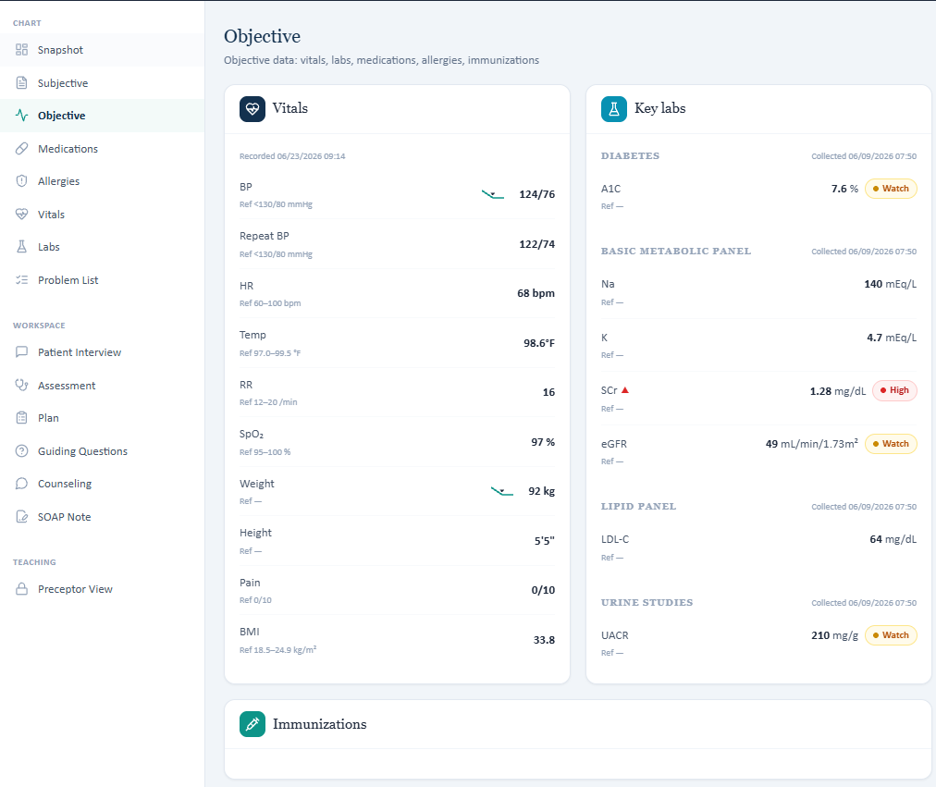
EMR evidence – the Immunizations section shown to the student has no vaccine details.
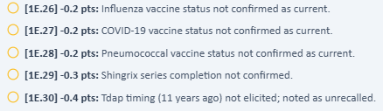
Grader evidence – specific vaccine status and Tdap timing are required.

Issue 10. Additional historical and lipid laboratory values are required by the grader but are not shown in the Thursday lab panel
What the student saw or heard: The Thursday lab panel shows the current A1C, sodium, potassium, creatinine, kidney function, UACR kidney-protein test, and LDL cholesterol. It does not show total cholesterol, HDL, or triglycerides, and it does not display all prior A1C/UACR values required for three-point trend scoring.
What the grader expected: The grader requires total cholesterol 152 mg/dL, HDL 47 mg/dL, triglycerides 160 mg/dL, previous A1C 7.9%, and previous UACR 330 mg/g in addition to the current values.
Why this is a problem: A student should not be expected to report numeric values that are not visible in the encounter data.
Suggested fix: Display every graded laboratory value and required prior trend value in the student-accessible lab history, or remove hidden values from grading.

EMR evidence – the visible Thursday lab panel does not show total cholesterol, HDL, or triglycerides.
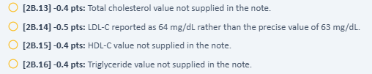
Grader evidence – the missing lipid values are still required for scoring.

Issue 11. Penicillin allergy reported by the AI patient conflicts with “No known drug allergies” in the EMR
What the student saw or heard: Linda reports a childhood penicillin reaction with rash and hives. The EMR allergy section says “No known drug allergies.”
What the grader expected: The grader and EMR should use the same reconciled allergy record as the AI patient, rather than a conflicting NKDA entry.
Why this is a problem: If someone followed the EMR without reconciling the interview, a true allergy could be missed.
Suggested fix: Reconcile the allergy list so the EMR and AI patient show the same allergy and reaction.
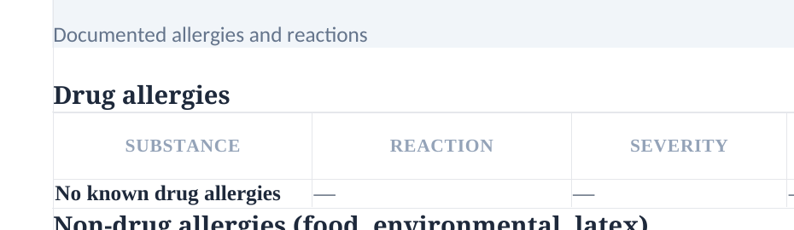
EMR evidence – the allergy section says “No known drug allergies.”

Interview evidence – Linda reports penicillin rash and hives.

